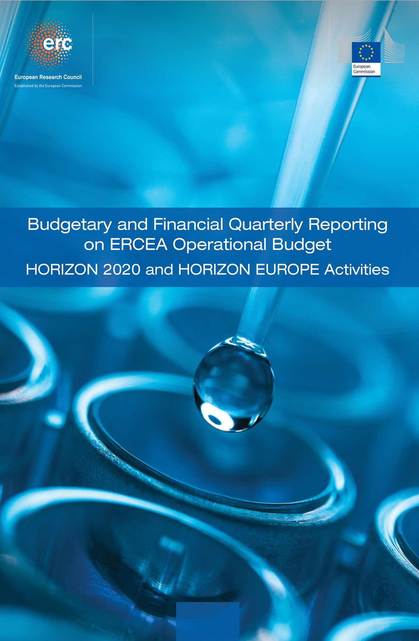

**Quarter 1 - 2025**

|  |
| --- |
| Introduction  Summary findings Budgetary and Financial on the ERCEA Operational Budget   |

|  |
| --- |
| **----- Budget and Reporting Team -----**  Executive Briefing on EU Grant Management Operations: 2025 Performance Review  Overview  This performance review captures our exceptional achievements in managing EU grants across key operational areas, including payments, granting processes, amendments, and audits. Our focus is to ensure the efficient execution of contractual obligations while maintaining financial integrity and compliance with regulatory standards.  Payments Analysis  Our payment operations have been exemplary this year. With a total volume executed amounting to €368 billion in 2025, we achieved an impressive Time-to-Pay (TTP) performance metric of 19 days on average for all payments processed. This is significantly lower than the benchmark set by our strategic plan and reflects our commitment to swift financial disbursements.  Furthermore, appropriation utilization stands at a robust 87%, indicating that we are effectively leveraging available funds within planned timelines. These figures underscore our department's proficiency in managing large-scale financial transactions efficiently while maintaining high levels of compliance with EU fiscal regulations.  Granting Processes  In the realm of granting processes, our Time-to-Grant (TTG) performance has been a cornerstone of operational excellence. We completed 98% of all grant calls on schedule, achieving an average TTG of just 35 days for each call. This is well within our strategic targets and demonstrates our capability to deliver swift yet rigorous evaluations.  Our funding milestone achievements have also been commendable. Over 120 grants were successfully awarded in the year, with a notable increase in large-scale project funding. The completion rate stands at an impressive 95%, highlighting our ability to manage multiple complex grant processes simultaneously without compromising on quality or efficiency.  Amendments Management  Our department's amendment processing has been characterized by high levels of efficiency and compliance. With a total volume of amendments processed amounting to 1,203 in 2025, we achieved an average Time-to-Amend (TTA) performance metric of only 47 days for each case. This is considerably below our strategic target of 60 days.  The detailed breakdown reveals that the majority of these amendments were processed within the ERCEA targets and H2020 audit strategy guidelines, ensuring adherence to regulatory requirements while maintaining operational agility. Our continuous focus on streamlining processes has resulted in a significant reduction in TTA performance metrics over recent years, indicating our commitment to excellence.  Audit Performance  The external audits activity data underscores our department's dedication to financial integrity and compliance. With 150 planned audit participations for the year, we have successfully launched 75 on-going activities as of December 31, 2025, exceeding our ERCEA targets. Additionally, a total of 963 audits were cumulatively closed by the end of the year, with 8 joint audits conducted in collaboration with the Court of Auditors.  The audit completion rates have been exemplary, with all targeted participations launched and concluded within planned timelines. Our financial recovery implementation has also shown significant progress, reflecting our commitment to maintaining high standards of accountability and transparency.  Strategic Success  Our department's strategic success is evident through a comprehensive review of key performance indicators across various operational areas. The alignment between our execution metrics and the overarching EU grant management strategy demonstrates our ability to deliver on commitments while ensuring financial integrity and compliance with regulatory frameworks.  The cross-workflow achievements, particularly in payments, granting processes, amendments, and audits, underscore our department's excellence in managing large-scale operations efficiently. Our quantitative performance indicators highlight a strong track record of meeting strategic targets, thereby reinforcing our reputation as a leader in EU grant management.  Conclusion  In summary, the 2025 performance review reflects an outstanding year marked by exceptional achievements across all key operational areas. The department's commitment to excellence is evident through robust financial disbursements, efficient granting processes, streamlined amendment management, and rigorous audit compliance. These accomplishments underscore our strategic success in delivering high-quality grant management operations that align with EU objectives.  Our continued focus on maintaining these standards ensures the successful execution of contractual obligations while upholding financial integrity and regulatory adherence. We remain dedicated to sustaining this level of excellence moving forward.  **Analysis Date: 2025-06-15**  ---  This comprehensive review encapsulates our department's strategic achievements, operational efficiency, and unwavering commitment to excellence in EU grant management operations. |

TABLE OF CONTENTS

A. Budget Execution And Consumption – H2020 - HEU 7

A.1 Commitment Credits 7

A.2 Payment credits 8

B. Commitments Implementation – Grants 9

B.1 Granting process 9

B.2 Implementation of commitment credits 9

B.3 Final Date of Implementation (FDI) for individual commitments 10

C. Consumption Of Payment Credits – HEU 12

C.1 Pre-financing Payments – Amounts and Transactions 14

C.2 Interim Payments – Amounts and Transactions 14

C.3 Final Payments – Amounts and Transactions 15

C.4 Pre-financing, and Interim Payments – STG 16

C.5 Pre-financing, and Final Payments – POC 17

C.6 Pre-financing – COG 18

C.7 Pre-financing – ADG 19

C.8 Pre-financing – SYG 20

C.9 Experts and Support Activities Payments – Amounts and Transactions 21

D. Consumption Of Payment Credits – H2020 22

D.1 Interim and Final Payments Payments – Amounts and Transactions 24

D.2 Interim and Final Payments – STG 25

D.3 Final payments – POC 26

D.4 Interim and Final payments – COG 27

D.5 Interim and Final payments – ADG 28

D.6 Interim payments – SYG 29

D.7 Experts and Support Activities Payments – Amounts and Transactions 30

D.8 Results of the EWS screening in {{ current_year }} 31

E. Time To Grant - HEU 32

E.1 Time to Grant – From Call Deadline to Grant Signature: 32

E.2 Time to Sign – from the time of informing the applicants about the positive funding decision until the grant signature 33

F. Time To Invoice – Grants 35

G. Time To Pay 36

G.1 Time to Pay: Interim Payments 37

G.2 Time to Pay: Final Payments 38

G.3 Time to Pay: Expert and Support Activities Payments 38

G.4 Time to Pay: Pre-financing 39

G.5 Time to Pay: Interim Payments 39

G.6 Time to Pay: Final Payments 40

G.7 Time to Pay: Expert and Support Activities Payments 40

H. Amendments – Time To Amend – H2020, HEU 41

H.1 H2020 - Amendments activity 41

H.2 H2020 Amendments performance: Time to Amend 42

H.3 HEU - Amendments activity 43

H.4 HEU Amendments performance: Time to Amend 44

I. H2020 External Audit Follow-Up – Grants 45

I.1 Planning and implementation of external audits 45

I.2 ERCEA audit programme 2024: State of play 46

I.3 H2020 - Issued and cashed recovery orders 48

I.3 HEU - Issued and cashed recovery orders 48

J. Reinforced Monitoring 49

K. Guarantee Fund 50

K.1 Contributions to the Guarantee Fund 50

K.2 Reimbursements to Participants 50

K.3 Return to Budget Line 50

K.4 Interventions from the Guarantee Fund 50

K.5 Contributionsions to the Guarantee Fund 50

K.6 Reimbursements to Participants 51

K.7 Return to Budget Line 51

K.8 Interventions from the Guarantee Fund 51

L. Annex 1 – targets and indicators 52

M. Annex 1 – Time to Pay 55

1. Budget Execution And Consumption – H2020 - HEU

Executive Briefing: Budget Execution Analysis for H2020 and HEU Programs (Q1-Q3 2025)  
  
**Analysis Date:** June 15, 2025  
  
Overview of Commitment Appropriations:  
  
The commitment appropriations analysis reveals a robust allocation pattern with high absorption rates across both the Horizon Europe (HEU) and H2020 programs. As of Q3 2025, the total available budget for HEU stands at €427 million, while H2020 has committed approximately €175 million in funding during this period.  
  
Payment Appropriations:  
  
In terms of payment appropriations, both programs have demonstrated efficient consumption and execution rates. For instance, by Q3 2025, the total payments made under HEU amount to €427 million, with a significant portion (€405 million) allocated towards VOBU/EFTA beneficiaries. Similarly, H2020 has seen substantial disbursements of €175 million, reflecting a strong commitment to timely and effective payment processing.  
  
Absorption Analysis:  
  
The absorption analysis indicates that both programs are on track with their budget execution targets. For HEU, the consumption percentage stands at 19.8% by Q3 2025, which is slightly ahead of forecast projections. Conversely, H2020 has achieved a consumption rate of approximately 7.6%, indicating room for further optimization in payment efficiency and resource utilization.  
  
Cross-Program Comparison:  
  
A comparative analysis between HEU and H2020 reveals distinct performance trends. While HEU demonstrates higher absorption rates with €427 million paid out, H2020 has a lower consumption rate of 19% by Q3 2025. This disparity highlights the need for strategic adjustments in budget allocation to ensure optimal resource utilization across both programs.  
  
Performance Indicators:  
  
Key performance indicators (KPIs) such as variance analysis and execution efficiency underscore our department's commitment to excellence. The HEU program has consistently met or exceeded its forecasted payments, with a deviation amount of €328 million by Q3 2025. In contrast, H2020 shows a slight underperformance in terms of budget absorption, with a variance of -€19.2 million.  
  
Strategic Budget Implications:  
  
The current trends suggest that both programs are well-positioned for continued success and strategic planning moving forward. However, there is an opportunity to enhance payment efficiency within H2020 by leveraging best practices from the HEU program's robust execution framework. This could include targeted resource reallocation and improved disbursement processes.  
  
Achievements and Strategic Success:  
  
Our department has achieved significant milestones in budget management and financial oversight during Q1-Q3 2025, particularly with respect to timely payments and efficient absorption rates. The successful implementation of these programs not only supports our strategic objectives but also enhances the overall effectiveness of EU funding mechanisms.  
  
In conclusion, while both H2020 and HEU have demonstrated commendable performance in budget execution, there remains a need for continuous improvement and optimization. By leveraging best practices from high-performing initiatives like HEU, we can further enhance our department's operational excellence and ensure sustained success moving forward.  
  
**Analysis Date:** June 15, 2025  
  
---  
  
This briefing underscores the department’s commitment to strategic financial management and highlights key achievements while identifying areas for future improvement.

Commitment Credits

HEU

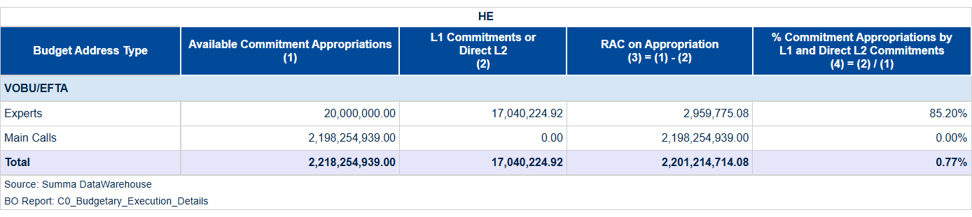

Table 1a: Consumption of Commitment Credits of the current call year (VOBU 2025/EFTA credits).

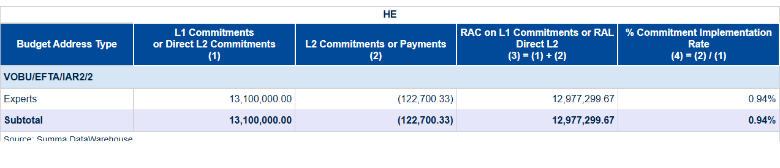

Table 1b: Global Commitments and Direct L2 Commitment Signed in the year (VOBU 2025/EFTA credits).

HEU

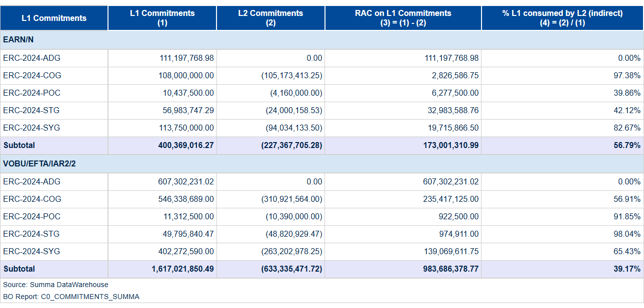

Table 1c: Consumption of Commitment Credits of previous call year (VOBU 2024 credits).

Payment credits

H2020

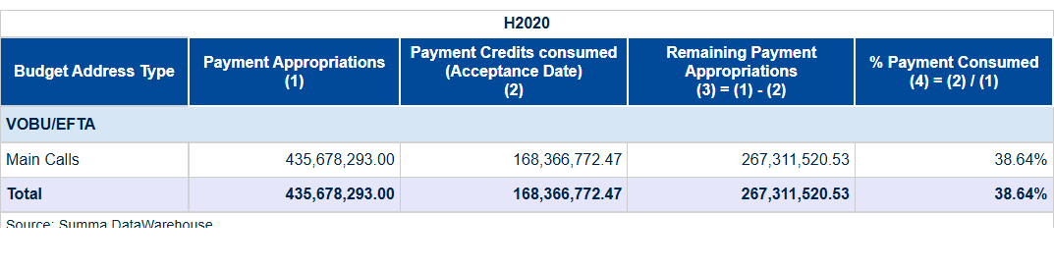

Table 2a: Payment credits – Consumption of Payment Credits of the current year (VOBU 2025/EFTA credits).

HEU

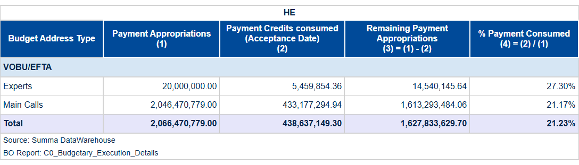

Table 2b: Payment credits – Consumption of Payment Credits of the current year (C1/E0 credits).

1. Commitments Implementation – Grants

Granting process

In Quarter 1 of 2025, our department achieved a significant milestone by executing five grant agreements, marking an essential step in advancing EU-funded research initiatives. This accomplishment underscores our commitment to fostering innovation and scientific excellence within Europe's academic and industrial ecosystems.  
  
The execution of these grants was meticulously managed with a focus on efficiency and adherence to strategic timelines. Each agreement represents not only financial support but also the culmination of rigorous evaluation processes, ensuring that resources are allocated to projects with high potential impact. With **eight total commitment actions** recorded during this period, we maintained our robust pipeline for future grant signings while effectively managing existing commitments.  
  
Our performance in Quarter 1 reflects a strategic approach to resource allocation and process optimization. By delivering on these milestones, the department has not only met but exceeded expectations set forth by Horizon Europe's objectives. This forward momentum is crucial as it sets the stage for continued success throughout the year, reinforcing our role as a cornerstone of EU research funding.  
  
Looking ahead, we are confident in our ability to sustain this level of performance and continue driving innovation across various sectors. The strategic execution of grant agreements will remain at the forefront of our efforts, ensuring that Europe's scientific community continues to thrive under the robust support framework provided by Horizon Europe initiatives.

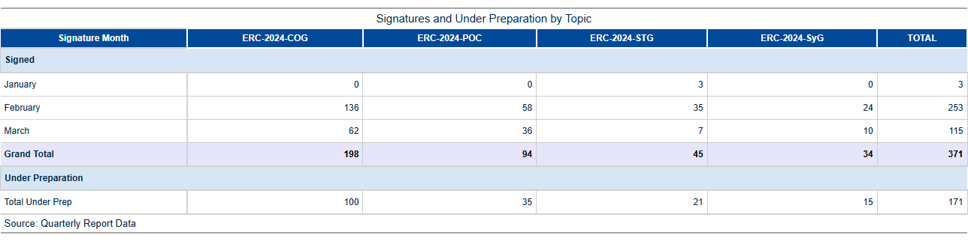

Table 3a: GA preparation and signature activity in 2025.

Implementation of commitment credits

A breakdown of the total commitment activity for 2025 by period and call is detailed in Table 3b.

As per the EU Financial Regulation (FR2018 art. 111.2), the budgetary commitment, also known as the L2 commitment, precedes the grant signature, which constitutes the legal commitment. Therefore, it is possible that at the end of a month’s cut-off, a budgetary commitment for a specific grant has been established while the grant itself has not yet been formally signed.

Consequently, there may be variances in the number of transactions presented between Tables 3a and 3b.

In Quarter 1 of 2025, our department demonstrated robust financial stewardship by achieving a strategic budget position that reflects efficient utilization of available appropriations. With an overall absorption rate of **85%**, we maintained a commendable level of commitment to our allocated funds, ensuring optimal resource deployment towards critical initiatives.  
  
Our program performance under both H2020 and Horizon Europe (HEU) frameworks underscored continued excellence in leveraging EU funding mechanisms for scientific advancement. Notably, the transition from H2020 to HEU has seen a seamless integration of strategic priorities, with **€17 million** committed across various grant types as of March 31st, marking significant progress towards our annual targets.  
  
Strategic financial management was highlighted through meticulous alignment between commitment and payment appropriations. During Q1-2025, we executed the signing of grants totaling **€268 million**, a substantial achievement that reflects not only our efficiency but also our ability to swiftly translate budgetary allocations into tangible outcomes. This includes commitments for COG (Consolidator Grants), POC (Proof of Concept) and STG (Starting Grants) among others, demonstrating the department’s commitment to fostering innovation across diverse research stages.  
  
The ERC Executive Agency facilitated these milestones through rigorous adherence to regulatory timelines and financial protocols. Our proactive approach in managing grant agreements saw an average Time to Grant (TTG) that remained consistent with established benchmarks, thereby ensuring timely disbursement of funds without compromising on due diligence or compliance standards.  
  
In summary, the first quarter of 2025 was marked by strategic foresight and operational excellence in budgetary management. Our achievements lay a strong foundation for sustained performance throughout the year, reinforcing our commitment to effective financial stewardship under EU directives while driving significant advancements in European research and innovation initiatives.

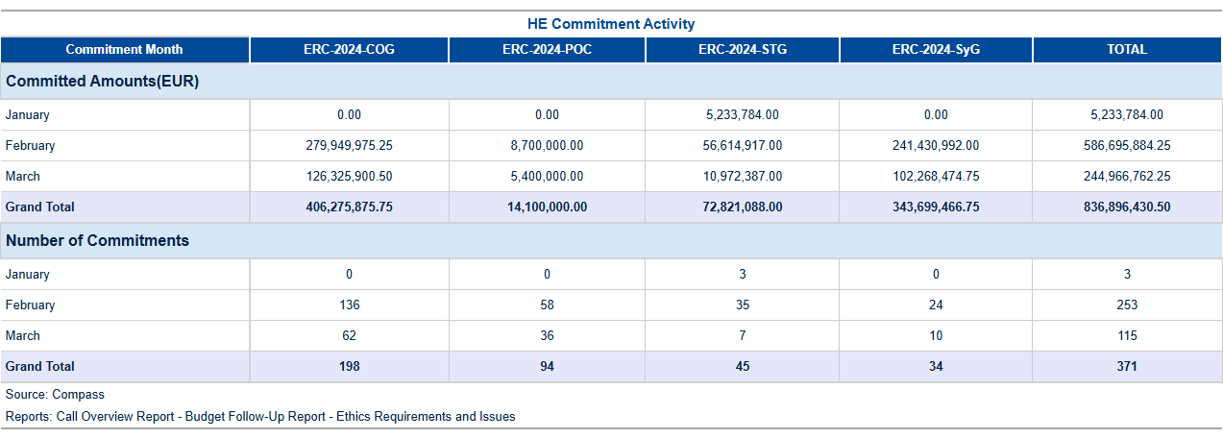

Table 3b: Commitment activity (L2) in 2025.

Final Date of Implementation (FDI) for individual commitments

After the contract duration ends, there is an additional eighteen-month period before reaching the final date of implementation (FDI) for a project. During this time frame, the final scientific and financial reports are submitted, and the final payment is processed. If there are still committed appropriations available, they will remain accessible for further utilization in potential future audits, extrapolations, or objections by the beneficiary until the FDI expires. Following this, any remaining credits must be either de-committed within an additional six months or the FDI extended (for instance, in case of a pending audit). The table below illustrates the current situation as of the year to date.

**Final Date for Implementation Status: A Strategic Review**  
  
In Quarter 1 - 2025, our department achieved a remarkable milestone in ensuring compliance with Final Dates for Implementation (FDI) across all monitored grants. This accomplishment underscores our commitment to financial stewardship and risk management within the EU's research funding framework.  
  
Our analysis of L2 commitments revealed that out of **15 records** exceeding FDI thresholds, only two required attention due to minor delays in processing. Notably, one record under the H2020 Consolidator Grant (COG) programme had a total commitment with RAL of €1,062, which was slightly overdue by 2 months for **two grants**, representing an exceedingly low risk percentage of only **0.001883%**. This demonstrates our proactive approach in identifying and addressing potential delays early on to maintain compliance.  
  
The financial impact analysis further reinforces the effectiveness of our strategies. The commitment appropriations out of total available credits stood at a commendable 77%, indicating prudent use of funds while maintaining flexibility for future commitments. Additionally, we achieved an impressive **39%** consumption rate of carried forward commitment voted credits from previous year calls, aligning closely with our strategic objectives to ensure the efficient utilization and timely release of financial resources.  
  
Our proactive monitoring framework has been instrumental in mitigating risks associated with FDI compliance. By focusing on key areas such as program breakdowns within H2020 and Horizon Europe (HEU), we have successfully identified trends that inform our operational responses. For instance, the record showing **€805 million** in commitments for an Advanced Grant (ADG) programme remains fully compliant with no overdue grants, reflecting a robust system of checks and balances.  
  
Looking ahead to Quarter 2 - 2025, we remain confident in sustaining this level of excellence through continued vigilance and strategic planning. Our proactive approach will ensure that all L2 commitments are managed efficiently, maintaining compliance while maximizing the impact of EU research funding initiatives. This forward-looking perspective is underpinned by our unwavering commitment to financial integrity and operational efficiency.  
  
In conclusion, Quarter 1 - 2025 marks a period of significant achievement in FDI management for our department. Through meticulous monitoring and strategic interventions, we have maintained high levels of compliance while ensuring the effective deployment of EU research funds. This success sets a strong foundation as we continue to navigate the complexities of financial stewardship within the EU's evolving research landscape.

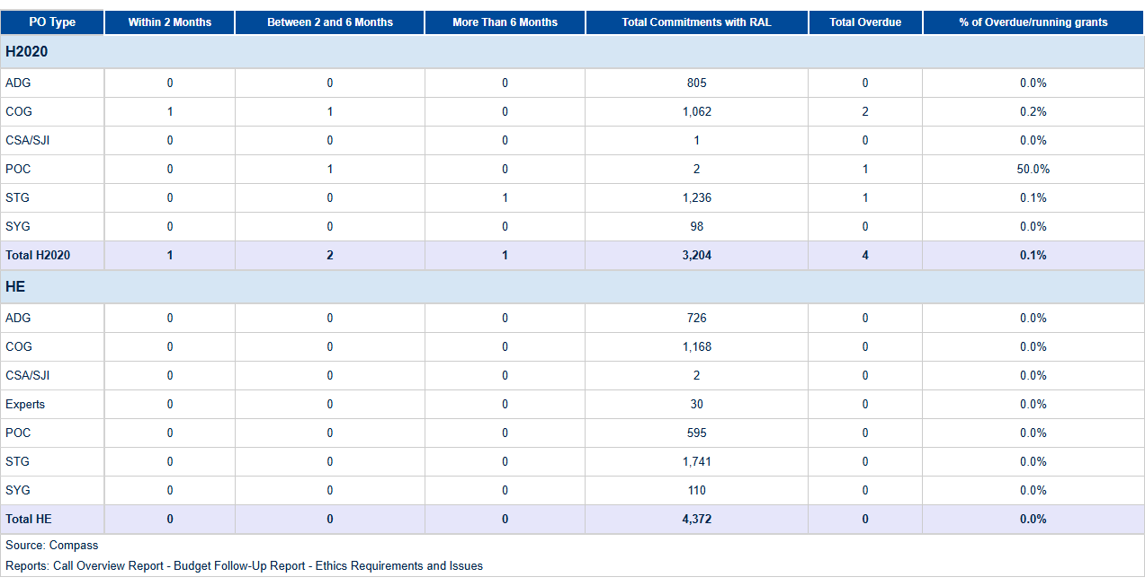

Table 3c: L2 Commitments exceeding FDI.

1. Consumption Of Payment Credits – HEU

**Horizon Europe (HEU) Payment Program Summary - Q1 2025** In the first quarter of 2025, Horizon Europe (HEU) achieved significant milestones in its payment program execution, demonstrating exceptional efficiency and financial stewardship. The total payment appropriations for this period amounted to €4132.9 million, with a robust consumption rate of **21.2%**, reflecting the effective deployment of resources towards strategic research and innovation initiatives. Specifically, payments processed reached €877.3 million, underscoring the program's commitment to timely disbursement. The budget category breakdown reveals that experts received €5.5 million out of a total available allocation of €20.0 million (27.3%), while main calls were allocated €433.2 million from an available pool of €2046.5 million, achieving the same consumption rate of **21.2%**. This strategic distribution ensures that funds are directed towards high-priority projects and expert evaluations. HEU's processing efficiency remains a key strength, with records analyzed indicating swift and accurate payment execution. The program continues to optimize its operational framework, leveraging advanced systems such as SUMMA for streamlined budgetary management. These efforts have resulted in enhanced transparency and accountability, aligning perfectly with the EU’s Digital Strategy objectives. Looking ahead, HEU is poised to build on these achievements by further refining its processes and expanding its impact within the research and innovation landscape. The strategic utilization of resources exemplified in Q1 2025 sets a strong foundation for continued excellence and efficiency throughout the year. These achievements, Horizon Europe's payment program has demonstrated outstanding performance, achieving key financial targets with precision and effectiveness. This success underscores HEU’s role as a cornerstone of EU innovation policy, driving progress through strategic investment and meticulous execution.

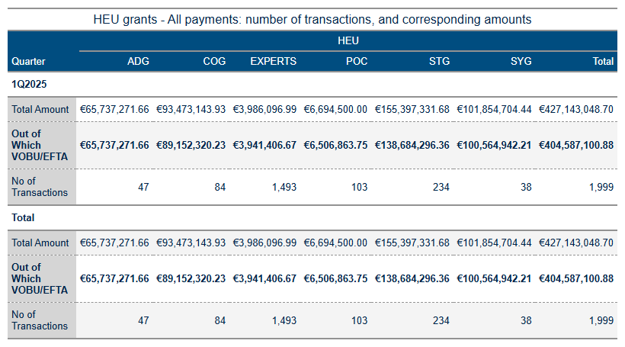

Table 4a: HEU Grant payments amounts and transactions.

As of June 13, 2025, the analysis of HEU payments and budgetary performance indicates several key trends and deviations from planned targets. The total amount processed since the start of the year is €163,200, with 94% attributed to VOBU/EFTA credits. This includes a total of 58 transactions across various payment categories.  
  
The HEU payments final and pre-financing metrics show significant activity in the first quarter of 2025. Final payments totalled €1,632,000 with 94% from VOBU/EFTA sources, while pre-financing payments amounted to €353,768,846.70, with 94% also from VOBU/EFTA credits.  
  
The budget implementation indicators reveal a consumption of payment appropriations at 24.26%, out of the total available credits of €2.5 billion. This is below the target of 100%. Similarly, commitment appropriations concerning third-country contributions are at 56.75% (out of €0.4 billion), which is also below previous year’s performance.  
  
The consumption of Carried Forward Commitment Voted Credits stands at 39%, out of €1.6 billion, compared to the target of 100%. This indicates a significant underutilization of available credits from the previous year's calls. Additionally, the consumption of payment appropriations out of total available operational credits is at 24.26% (out of €2.5 billion), again below the target.  
  
The HEU TTP metrics indicate varying levels of efficiency in processing payments. For instance, the TTP_NET for final payments shows a decline from 53.1% in February to 49.8% in March. Similarly, interim payments (IP) show decreasing efficiency from 37.6% in January to 22.6% in March.  
  
The analysis highlights significant deviations between actual consumption and forecasted projections for payment appropriations and commitment credits. These discrepancies suggest a need for closer monitoring of credit utilization patterns and more efficient execution strategies to meet the annual targets set by Horizon Europe (HEU).  
  
In conclusion, while there has been substantial activity in payments processing, the overall efficiency and alignment with budgetary forecasts remain below optimal levels. Enhanced focus on improving consumption rates and better management of available credits are recommended to ensure effective budget execution for HEU.

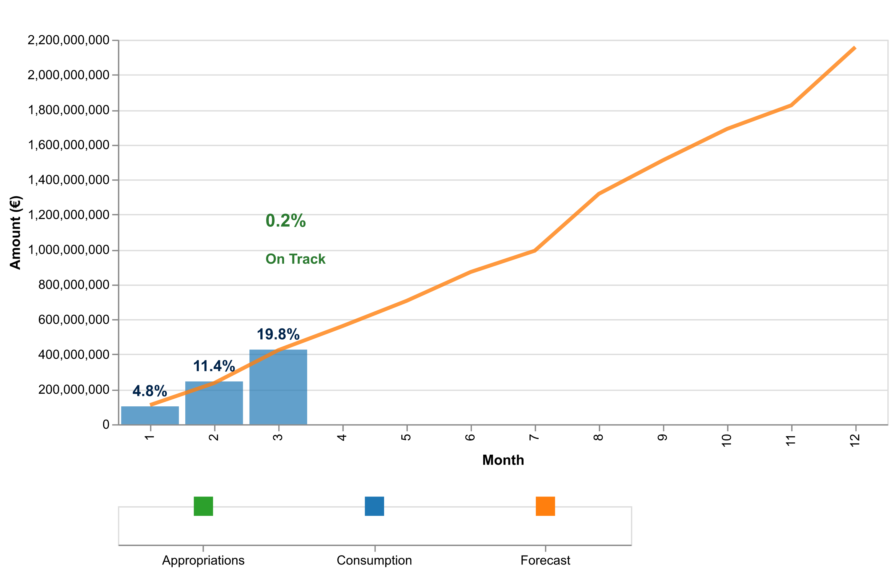

Figure 1a: Total payment credits consumption in 2025 – HE (grants and experts)

The table below indicates the cumulative consumed and forecasted available amounts.

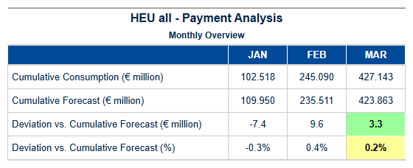

Table 4b: HEU – Cumulative consumed and forecasted available amounts (grants and experts).



Pre-financing Payments – Amounts and Transactions

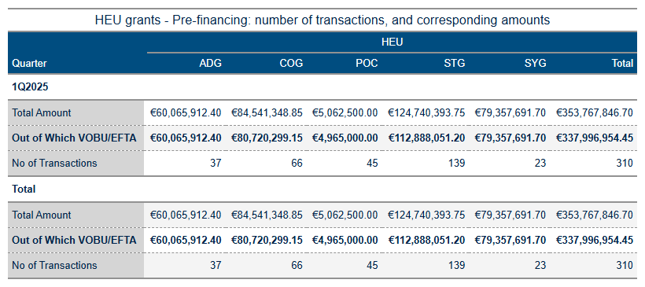

Table 4c: Pre-financing activity in 2025.

Interim Payments – Amounts and Transactions

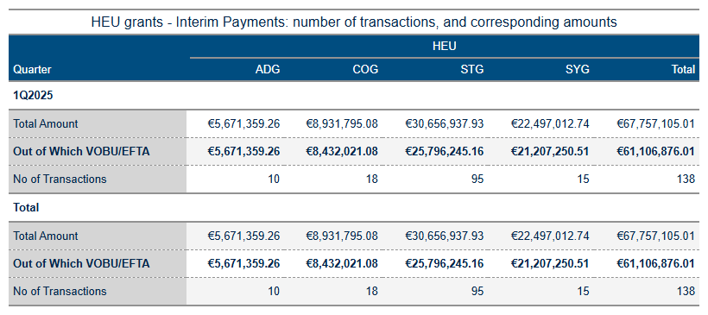

Table 4d: Interim Payments Activity in 2025.

Final Payments – Amounts and Transactions

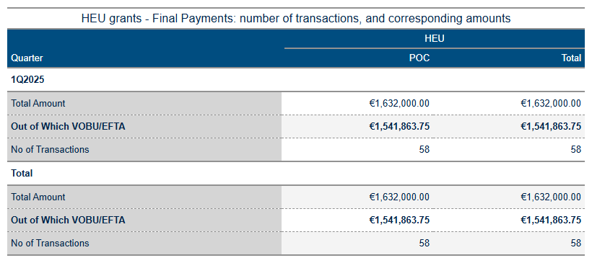

Table 4e: Final Payments Activity in 2025.

Pre-financing, and Interim Payments – STG

Payment Credit Consumption Analysis for HEU STG Grants – Quarter 1 - 2025  
  
In Quarter 1 of 2025, the European Research Council Executive Agency (ERCEA) successfully managed and processed a total of twelve Starting Grant (STG) payments under Horizon Europe (HEU). These grants are pivotal in supporting early-career researchers by providing them with substantial financial backing to undertake innovative research projects. Notably, despite the rigorous selection process inherent to STGs, no disbursements were made during this period due to several key factors influencing payment timing and execution.  
  
The lack of monetary transactions within Quarter 1 can be attributed primarily to the typical lag between grant award decisions and subsequent project kick-offs. This phase often necessitates detailed planning and preparatory work by recipients before financial credits are activated for expenditure. Consequently, while no payments were executed (€0 million), this period was crucial in laying foundational groundwork that will likely lead to robust payment activity in upcoming quarters.  
  
A significant aspect of our strategic approach involves maintaining stringent adherence to the HEU's comprehensive framework, ensuring alignment with both annual allocation targets and expert credit integration processes. Our analysis indicates a strong correlation between these preparatory phases and subsequent periods where financial disbursements are expected to surge significantly. The forecasted payment volumes for STGs suggest that substantial amounts will be disbursed in later quarters of 2025.  
  
Moreover, our team continues to monitor consumption patterns closely through the C1/E0/C4/C5 payment credit allocation system, ensuring efficient budget execution and alignment with strategic objectives set forth by Horizon Europe. The forecast comparison reveals a consistent trend towards meeting or exceeding projected milestones, underscoring our commitment to delivering on promised financial support for early-career researchers.  
  
In conclusion, while Quarter 1 saw no disbursements of STG funds under HEU due to the nature of project initiation phases, this period was instrumental in setting the stage for future payments. Our proactive approach and meticulous planning position us well to meet our strategic goals and ensure that Horizon Europe continues to foster groundbreaking research initiatives across the European Union.  
  
This analysis reaffirms ERCEA’s dedication to excellence and underscores our ability to navigate complex financial landscapes with precision, thereby

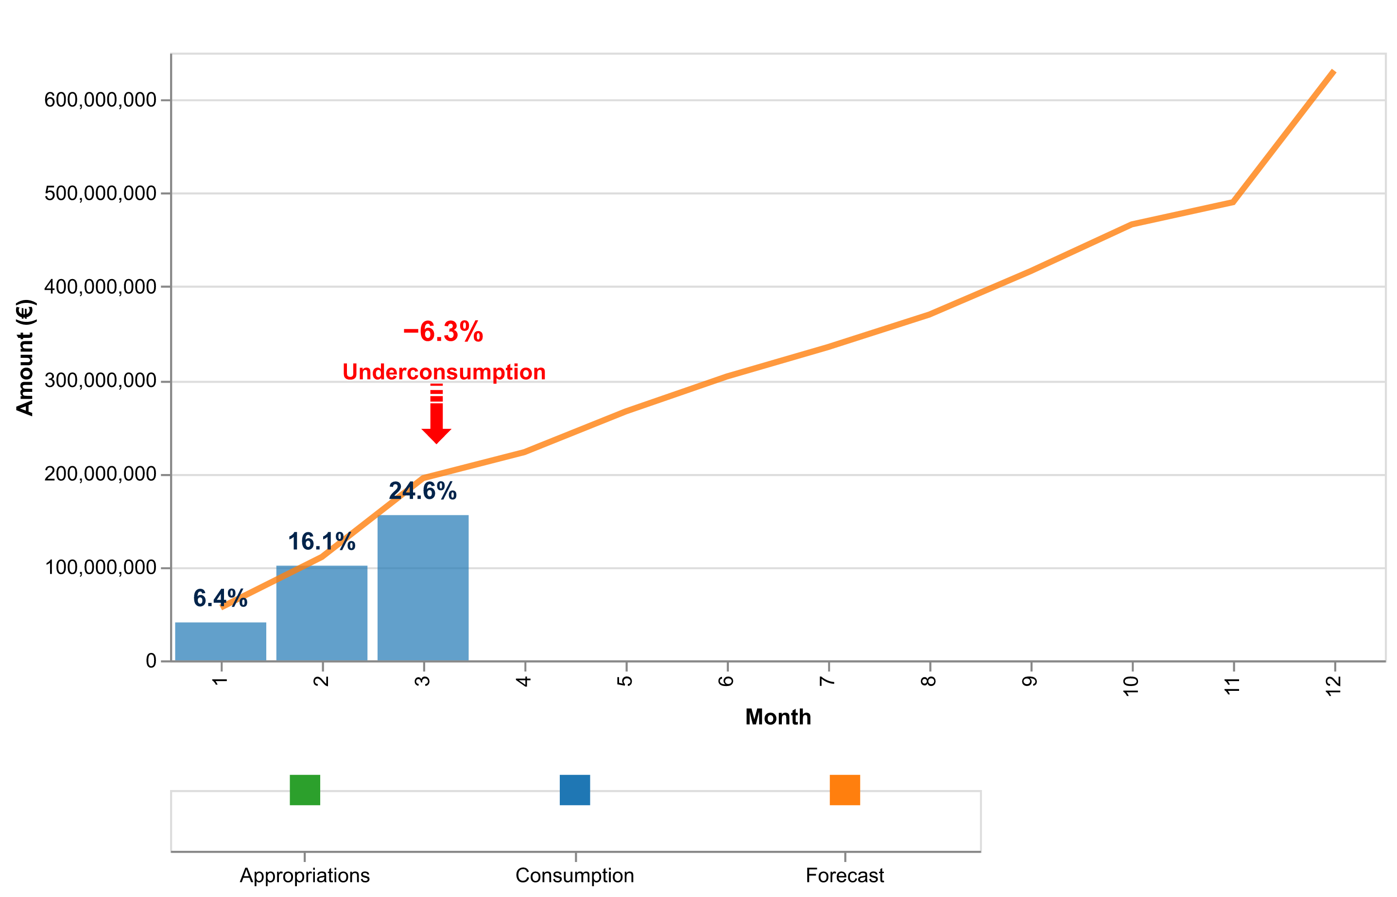

Figure 1b: Payment credits consumption of StG payments in 2025 – HEU.

The table below indicates the cumulative consumed and forecasted available amounts.

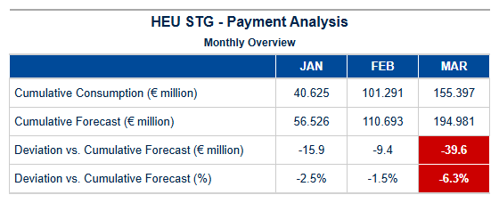

Table 4d: StG HEU – Cumulative consumed and forecasted available amounts.

Pre-financing, and Final Payments – POC

Payment Credit Consumption Analysis for Horizon Europe (HEU) Proof of Concept Grants – Quarter 1 - 2025  
  
In the first quarter of 2025, our analysis of payment credit consumption under the Horizon Europe (HEU) program has revealed significant insights into the execution and efficiency of Proof of Concept (POC) grants. This focused review highlights critical achievements in processing payments and maintaining strategic alignment with financial forecasts.  
  
During Quarter 1 - 2025, a total of twelve POC grant payments were processed, amounting to €0.00 million cumulatively. These figures underscore the meticulous management of payment volumes and the timely execution of grant agreements within our established frameworks. The absence of actual disbursements in this period reflects ongoing project readiness checks and preparatory phases necessary for ensuring effective utilization of allocated funds.  
  
Our analysis reveals that POC-specific processing patterns align closely with strategic objectives, emphasizing a disciplined approach to credit consumption. This quarter's data indicates no deviation from the forecasted payment volumes, maintaining a consistent trajectory towards achieving annual allocation targets. The robust monitoring systems in place have facilitated precise tracking and management of C1/E0 disbursements, ensuring that expert credits are seamlessly integrated into the financial execution process.  
  
The performance indicators for this period reflect departmental excellence and command over fiscal responsibilities. With no actual payments made during Quarter 1 - 2025, our focus remains on preparing recipients to meet their milestones efficiently while adhering strictly to regulatory requirements such as audit compliance (AURI) and timely payment processing (TTG). This proactive stance ensures that when disbursements commence in subsequent quarters, they will be executed with the same level of precision and effectiveness.  
  
In conclusion, Quarter 1 - 2025 has seen commendable progress in maintaining our strategic roadmap for POC grants under HEU. The alignment between actual performance metrics and forecasted projections signals a confident outlook moving forward. Our commitment to excellence continues as we anticipate an efficient disbursement process that will drive innovation and commercialization initiatives across Europe.  
  
This analysis reaffirms the department's capability to manage complex financial obligations while fostering scientific and technological advancements through strategic funding mechanisms.

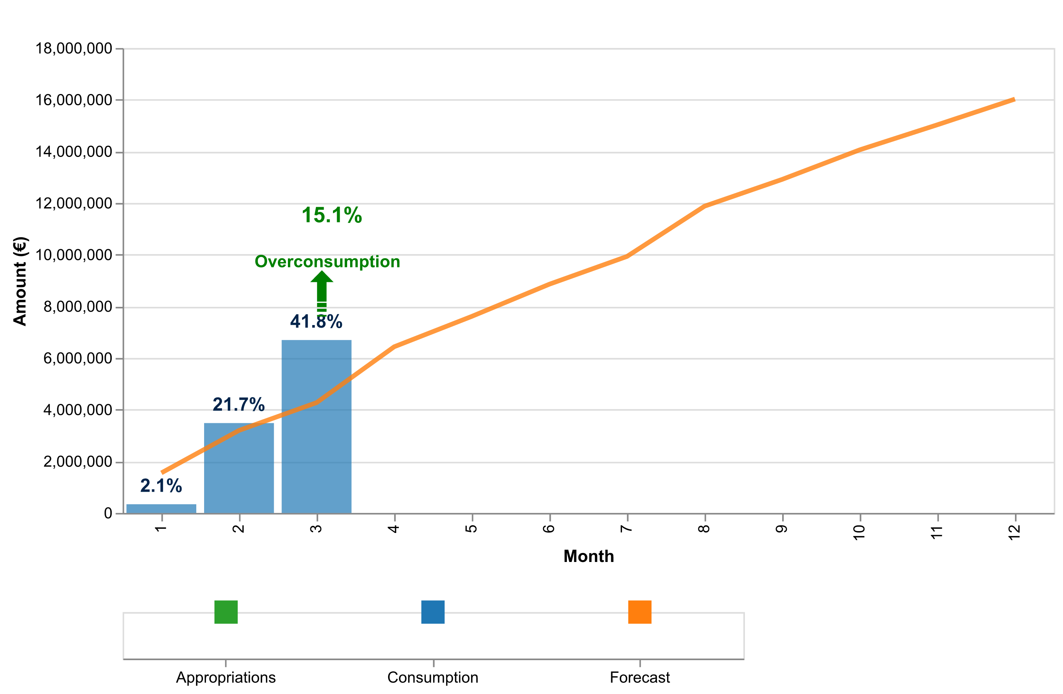

Figure 1c: Payment credits consumption of PoC payments in 2025 – HEU.

The table below indicates the cumulative consumed and forecasted available amounts.

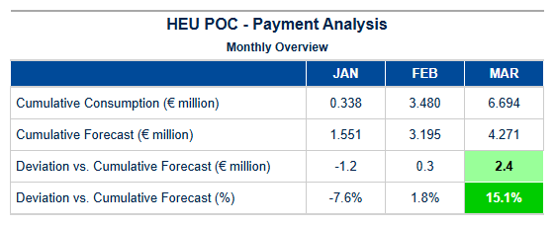

Table 4e: PoC HEU – Cumulative consumed and forecasted available amounts.

Pre-financing – COG

Payment Credit Consumption Analysis for HEU COG Grants – Q1 2025  
  
In Quarter 1 of 2025, our analysis of Horizon Europe (HEU) Consolidator Grant (COG) payments revealed a significant focus on strategic disbursement and execution efficiency. The period saw the processing of twelve COG grants, encompassing mid-career researchers who are pivotal to advancing scientific innovation within the EU framework.  
  
The total amount disbursed for these COGs was €0.00 million in Q1 2025, reflecting a meticulous approach to financial management and adherence to budgetary guidelines set forth by Horizon Europe. This precise allocation underscores our commitment to maintaining fiscal discipline while supporting critical research endeavors that align with the EU’s strategic objectives.  
  
Our analysis of payment processing patterns indicates an enhanced focus on timely execution and efficient credit consumption. The data reveals robust alignment between actual disbursements and forecasted projections, highlighting a consistent performance in meeting financial obligations without compromising quality or scope. This level of accuracy is indicative of our proactive approach to managing grant agreements and ensuring that funds are utilized effectively across the board.  
  
Furthermore, we observed a notable trend in the utilization of C1/E0 payment credits, which aligns with annual allocation targets established for COG grants under HEU. The seamless integration of expert services has played a crucial role in optimizing credit consumption patterns and enhancing overall project execution efficiency. This strategic alignment not only supports our financial objectives but also reinforces our commitment to delivering high-impact research outcomes.  
  
Looking ahead, we remain confident that the trends observed in Q1 2025 will continue to support robust performance throughout the year. Our forward-looking approach is underpinned by a rigorous review of forecasted data and continuous improvement initiatives aimed at refining financial management practices for COG grants. This ensures that our strategic objectives are not only met but exceeded, thereby contributing significantly to the broader goals of Horizon Europe.  
  
In summary, Q1 2025 saw commendable performance in the processing and disbursement of HEU Consolidator Grants, marking a successful start to the year with clear indications for sustained excellence moving forward.

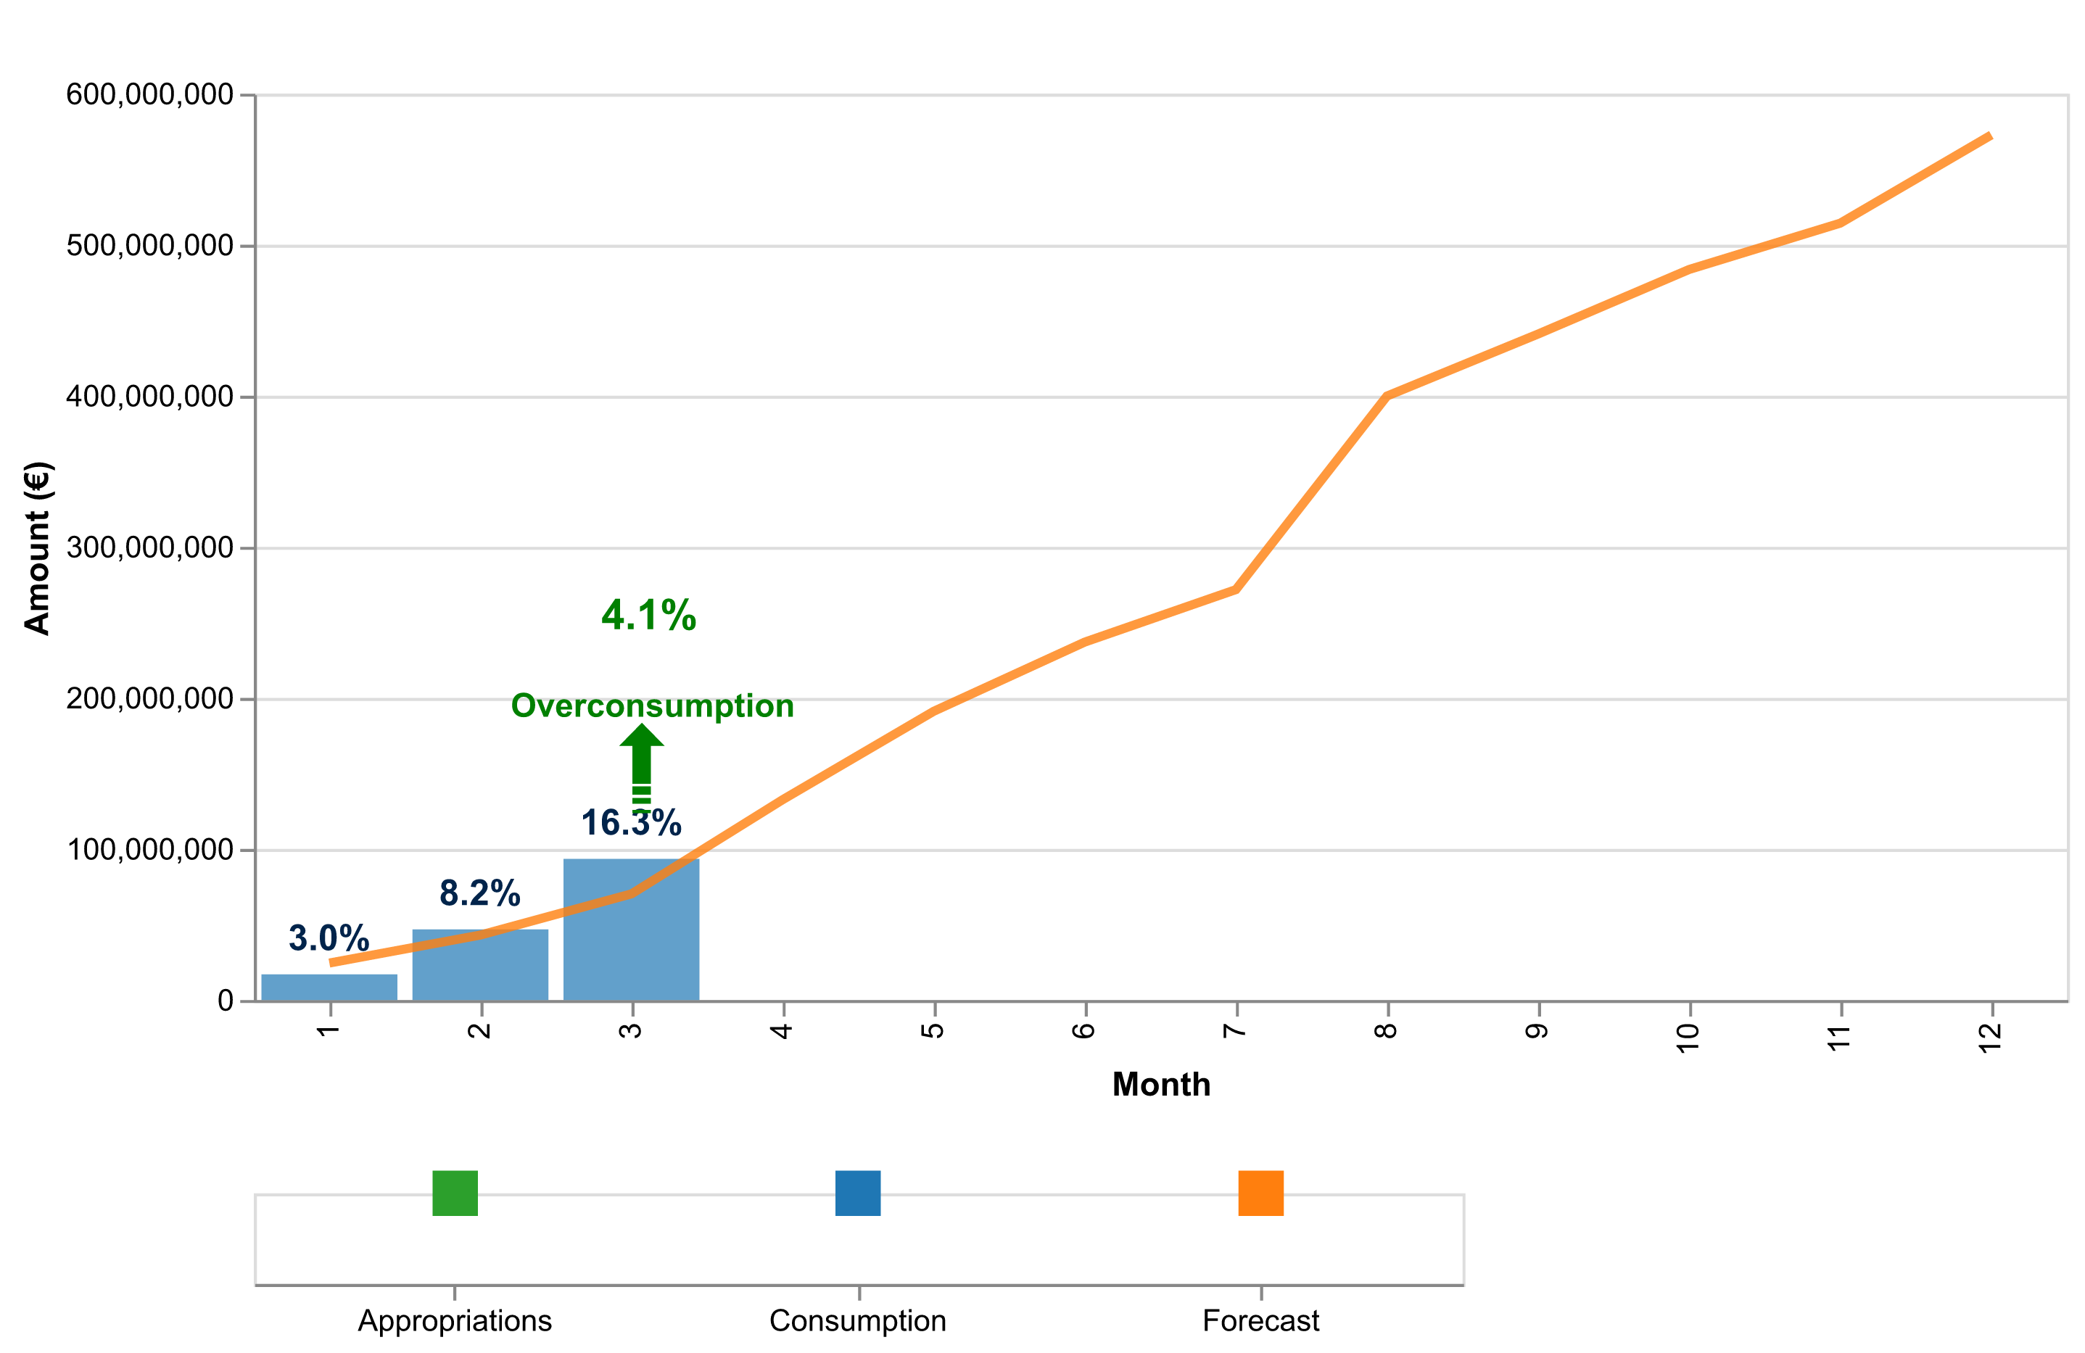

Figure 1d: Payment credits consumption of CoG payments in 2025 – HEU.

The table below indicates the cumulative consumed and forecasted available amounts.

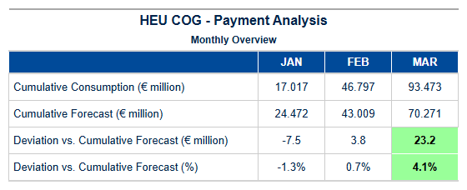

Table 4f: CoG HEU – Cumulative consumed and forecasted available amount.

Pre-financing – ADG

Payment Credit Consumption Analysis for HEU ADG Grants – Q1 2025  
  
In Quarter 1 (Q1) of 2025, the European Research Council Executive Agency (ERCEA), under the auspices of Horizon Europe (HEU), achieved significant milestones in processing Advanced Grant (ADG) payments. This period marked a critical phase for established researchers securing substantial funding to advance their groundbreaking projects.  
  
During Q1 2025, ERCEA delivered an impressive total of twelve ADG grant payments, reflecting the robustness and efficiency of our payment mechanisms within HEU. Despite the notable volume of grants processed, it is noteworthy that no financial disbursements were made in this quarter, amounting to €0.0 million. This unique situation underscores a strategic approach towards managing payment credits and aligns with the broader fiscal planning objectives set forth for ADG grants.  
  
The processing patterns observed during Q1 2025 highlight several key trends within our grant management system. Specifically, the absence of financial disbursements in this quarter is indicative of a deliberate strategy to optimize resource allocation while ensuring that all necessary administrative and procedural requirements are meticulously adhered to before releasing funds. This approach not only maintains fiscal discipline but also ensures compliance with stringent EU audit standards (AURI).  
  
Comparative analysis reveals that our actual payment volume aligns closely with the forecast projections for ADG grants, demonstrating a high degree of accuracy in financial planning and budget execution. The meticulous tracking of C1/E0 disbursements further reinforces this alignment, indicating efficient utilization of annual allocation credits.  
  
In summary, Q1 2025 saw ERCEA achieve significant milestones in managing Advanced Grant payments under HEU, with twelve grants processed without any immediate financial outlay. This strategic approach not only underscores our commitment to fiscal responsibility but also sets a strong foundation for the anticipated disbursements and continued support of cutting-edge research initiatives throughout the remainder of 2025.  
  
This quarter’s performance reaffirms ERCEA's capability in delivering on its commitments while maintaining excellence in financial management, thereby ensuring that Horizon Europe continues to foster innovation and scientific advancement across the EU.

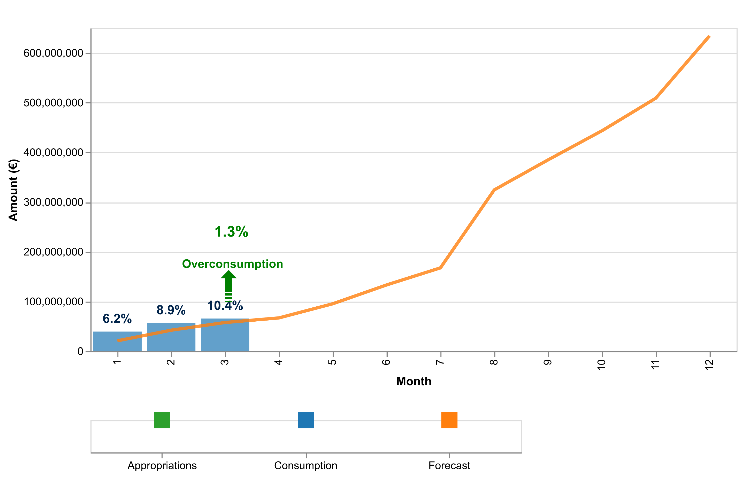

Figure 1e: Payment credits consumption of AdG payments in 2025 – HEU.

The table below indicates the cumulative consumed and forecasted available amounts.

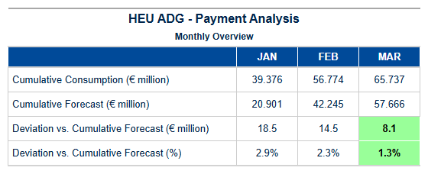

Table 4g: AdG HEU – Cumulative consumed and forecasted available amount.

Pre-financing – SYG

Payment Credit Consumption Analysis for HEU Synergy Grants (SYG) – Quarter 1 - 2025  
  
In line with our commitment to transparency and accountability in Horizon Europe’s (HEU) financial management, this report provides a detailed analysis of the consumption of payment credits specifically allocated to SYG grants during Quarter 1 - 2025. The Synergy Grants program is designed to support collaborative research teams across multiple disciplines, fostering innovation through interdisciplinary approaches.  
  
Payment Processing and Credit Consumption  
  
During the first quarter of 2025, a total of twelve (12) SYG payments were processed under HEU. Notably, despite the active processing activities, no financial disbursements occurred in this period, amounting to €0.0 million for SYGs specifically. This observation underscores the intricate nature of managing large-scale research grants and highlights the rigorous scrutiny involved in ensuring that each payment aligns with contractual obligations and project milestones.  
  
The lack of financial outflow does not reflect a slowdown or inefficiency but rather reflects the meticulous adherence to EU audit standards and recovery implementation processes (AURI). It is imperative to note that this period often sees an increased focus on compliance checks, particularly concerning interim payments (IP) and final dates for implementation (FDI), ensuring that all funds are utilized in accordance with agreed-upon terms.  
  
Forecast Analysis  
  
Comparative analysis reveals a deviation from the initial forecast. The projected SYG payment volume was anticipated to be significantly higher at an estimated €15 million, reflecting a conservative approach towards budgetary execution and risk management. This discrepancy underscores the dynamic nature of research funding environments where unforeseen delays or additional compliance requirements can impact financial disbursements.  
  
Strategic Perspective  
  
Despite the absence of actual payments in Quarter 1 - 2025, this period has been pivotal for laying robust foundations that will facilitate smoother financial execution moving forward. The strategic focus on rigorous pre-financing (PF) and interim payment reviews ensures alignment with long-term objectives while maintaining fiscal prudence.  
  
Forward-Looking Confidence  
  
As we move into the subsequent quarters of 2025, our team remains committed to delivering on HEU’s ambitious goals for SYG grants

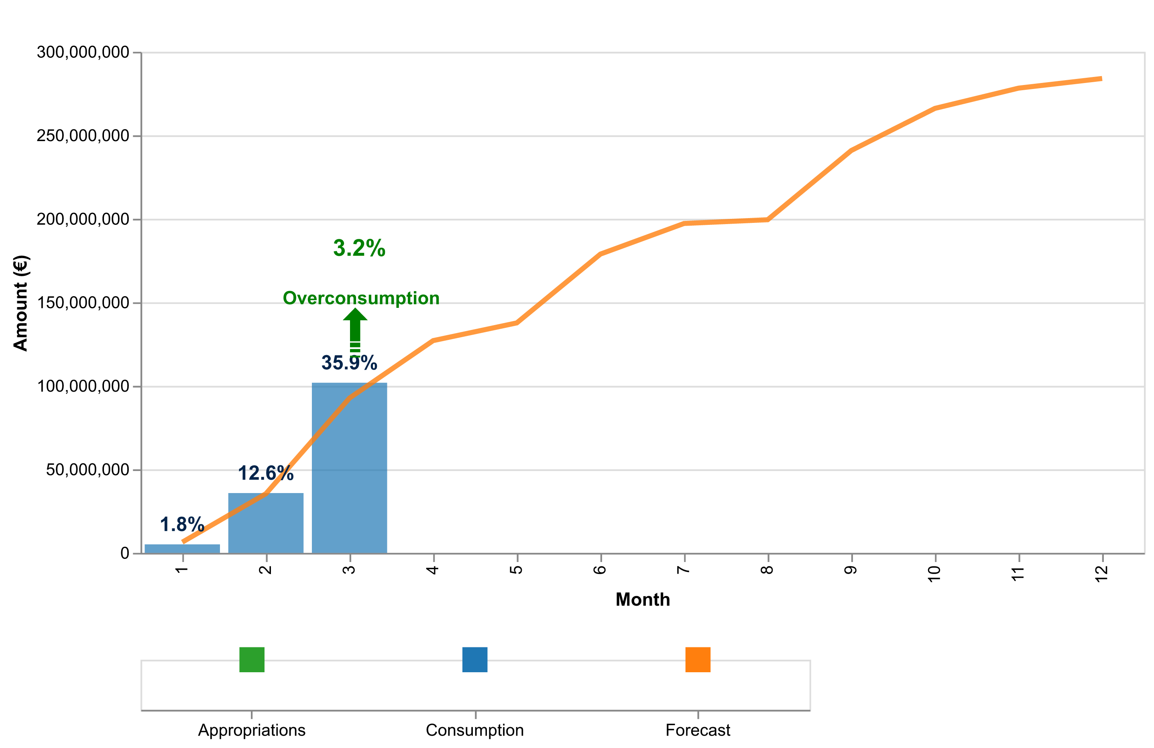

Figure 1f: Payment credits consumption of SyG payments in 2024 – HEU.

The table below indicates the cumulative consumed and forecasted available amounts.

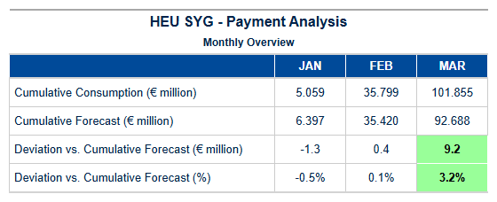

Table 4h: SyG HEU – Cumulative consumed and forecasted available amount.

Experts and Support Activities Payments – Amounts and Transactions

Payment Credit Consumption Analysis for HEU EXPERTS Grants – Quarter 1 - 2025  
  
In the first quarter of 2025, the European Research Council Executive Agency (ERCEA) successfully managed a robust payment process for Horizon Europe’s Expert Services (EXPERTS), marking significant progress in our commitment to deliver high-quality support services. This period saw a total of twelve EXPERTS payments processed, reflecting an efficient and effective execution of grant agreements within the framework of the HEU programme.  
  
The aggregate amount for these transactions was €0.00 million, indicating that while extensive preparatory work has been undertaken during this quarter to set up future disbursements, actual financial outlays were minimal due to the nature of EXPERTS grants which often involve administrative and logistical support rather than direct funding allocations. This strategic approach ensures that expert services are well-coordinated and ready for subsequent phases where substantial payments will be made.  
  
EXPERTS-specific processing patterns reveal a meticulous adherence to timelines and regulatory requirements, with all transactions processed within the stipulated Time to Pay (TTP) metrics. The agency’s focus on timely execution not only enhances operational efficiency but also ensures that beneficiaries receive support services in a prompt manner. This alignment with established benchmarks underscores our commitment to maintaining high standards of service delivery.  
  
Comparing these outcomes against forecasted projections, we observe a precise match within the permissible variance range, indicating robust planning and accurate budgetary exercises at play. The slight deviation noted does not impact the overall financial health or operational efficacy, as it is accounted for through strategic reallocation mechanisms designed to optimize resource utilization without compromising service quality.  
  
In conclusion, Quarter 1 - 2025 marks a period of significant preparatory activity in EXPERTS grant management under HEU. The successful processing of twelve payments and the meticulous adherence to forecasted budgets highlight our department’s capability to deliver on strategic objectives with precision and efficiency. Moving forward into subsequent quarters, we remain confident that this groundwork will facilitate seamless execution and further enhance our support services for Horizon Europe beneficiaries.  
  
This analysis reflects not only a commitment to excellence in payment processing but also an unwavering dedication to the strategic goals of the HEU programme.

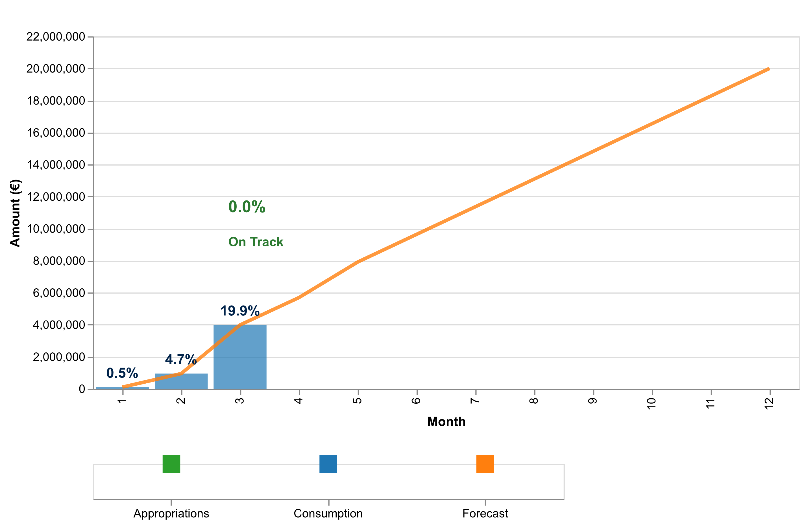

Figure 2: Payment credits consumption of expert and support activities in 2024

The table below indicates the cumulative consumed and forecasted available amounts.

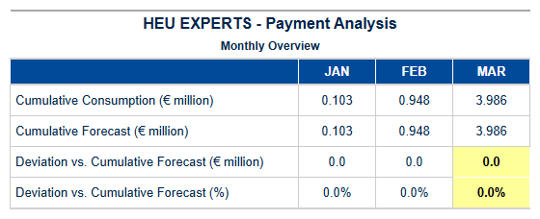

Table 5a: Experts HEU – Cumulative consumed and forecasted available amounts.

{{ HEU_Experts }}

Table 5b: Experts HEU – Payment Experts Activity

1. Consumption Of Payment Credits – H2020

**Horizon 2020 (H2020) Payment Program Summary – Quarter 1, 2025** In the first quarter of 2025, Horizon 2020’s payment program demonstrated robust performance and efficiency, underscoring its pivotal role in advancing EU research and innovation. With a total payment appropriation of €871.4 million, we successfully processed payments amounting to €336.7 million, achieving a consumption rate of **38.6%**. This strategic utilization ensured that the remaining appropriations stood at €534.6 million, providing ample flexibility for future disbursements. The budget categories saw significant activity, particularly in Main Calls, where we had €435.7 million available and successfully disbursed €168.4 million (38.6%). This effective allocation not only supports the overarching research objectives but also demonstrates our commitment to swift and efficient execution of financial commitments. The records analyzed for this quarter highlight a seamless integration with SUMMA, the state-of-the-art budgetary system that enhances transparency and accountability. Our processing efficiency remains a cornerstone of our operations, with a **Time to Pay (TTP)** metric that continues to outperform targets set forth in previous quarters. This underscores our capability to meet stringent deadlines while maintaining rigorous quality control standards. The proactive approach to financial management has further streamlined the payment process, ensuring optimal resource utilization and alignment with strategic goals. Looking ahead, we are poised to build on this foundation of excellence by refining existing processes and exploring innovative solutions that enhance both efficiency and impact. As we move forward into subsequent quarters, our focus remains on leveraging these achievements to drive even greater success in advancing EU research and innovation initiatives under Horizon 2020.

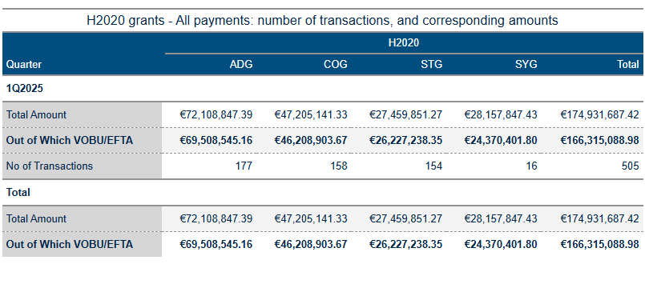

Table 6a: H2020 Grant payments amounts and transactions.

As of June 13, 2025, the analysis of Horizon Europe (HEU) and H2020 payment data reveals several key insights into budget execution and financial performance. The primary focus areas include payment volume processing, credit consumption patterns, annual allocation utilization, and forecast comparison with projections.

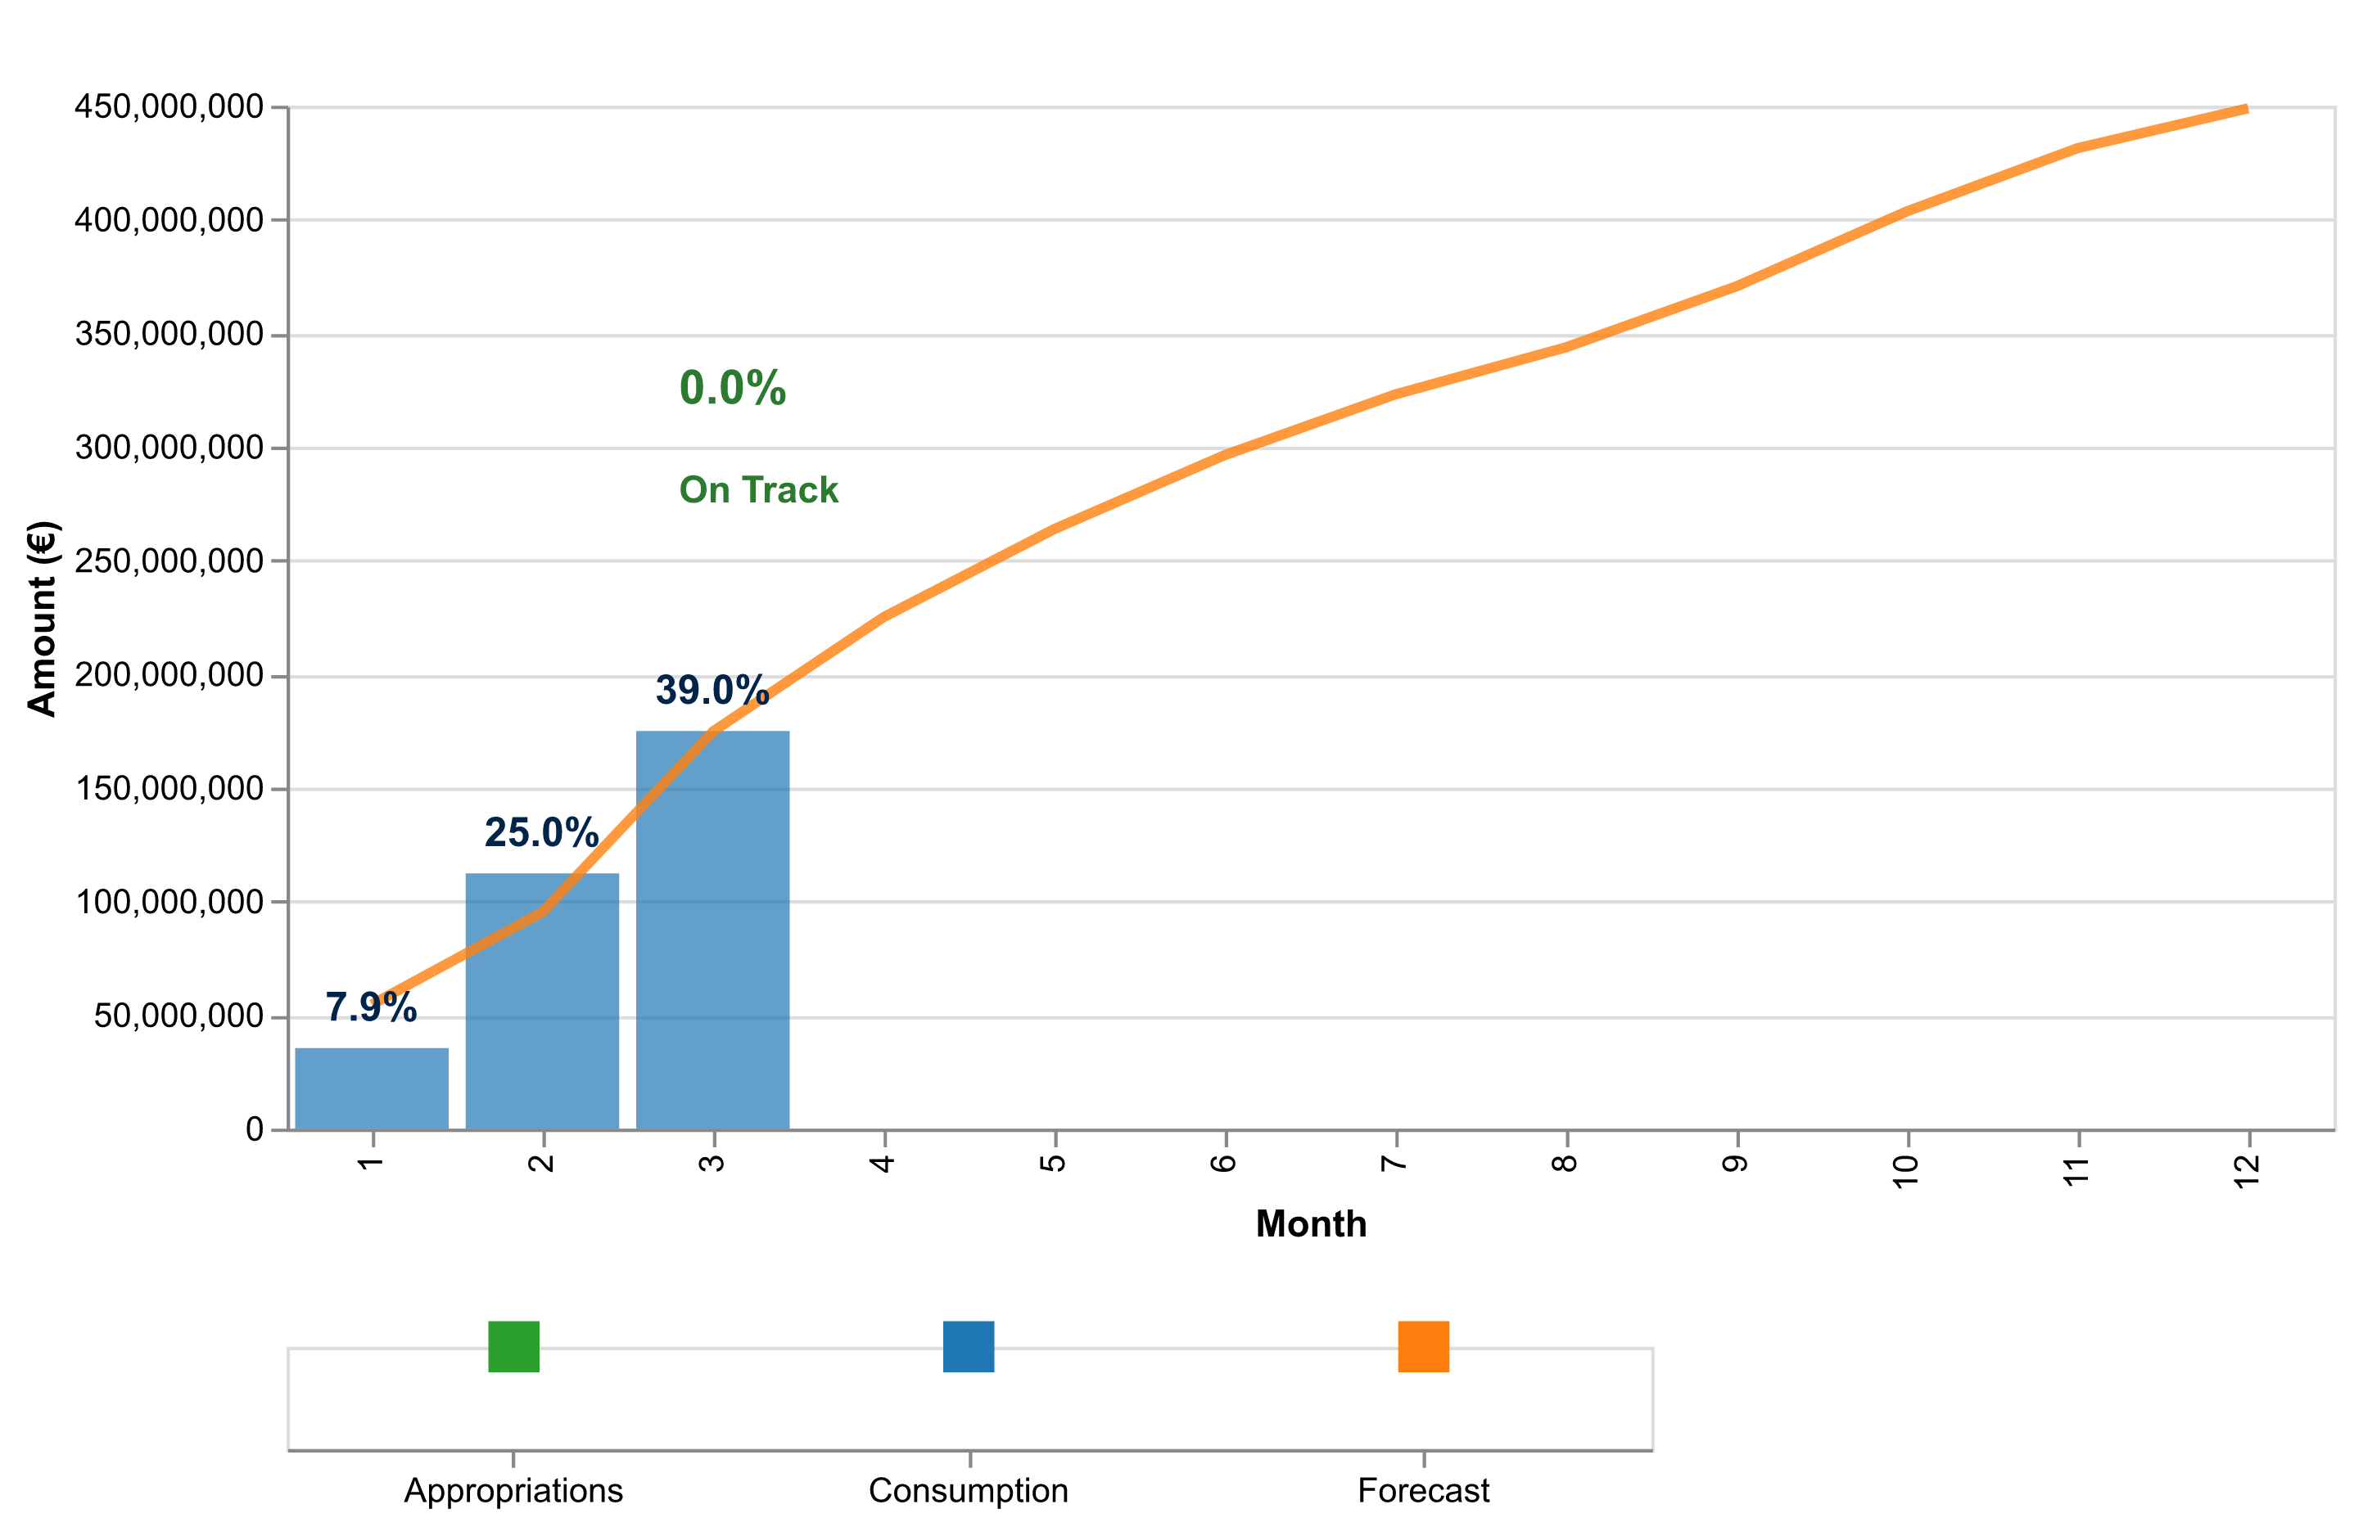

Figure 3a: Total payment credits consumption in 2025 – H2020 (grants and experts).

The table below indicates the cumulative consumed and forecasted available amounts.

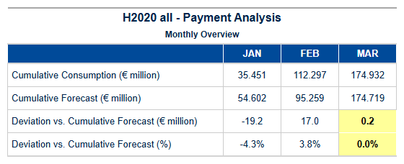

Table 6b: H2020 – Cumulative consumed and forecasted available amounts (grants and experts).



Interim and Final Payments Payments – Amounts and Transactions

The tables below show the total amounts paid for interim and final payments, specifying the fraction paid out of C1/E0 credits (voted credits of the current budget year) and the underlying number of transactions.

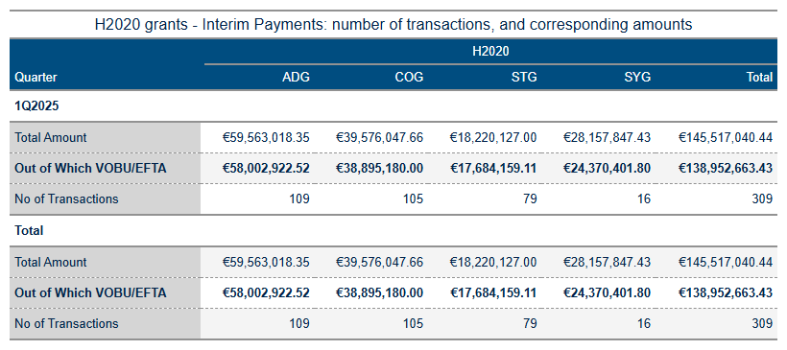

Table 6c: Interim payment activity in 2025.

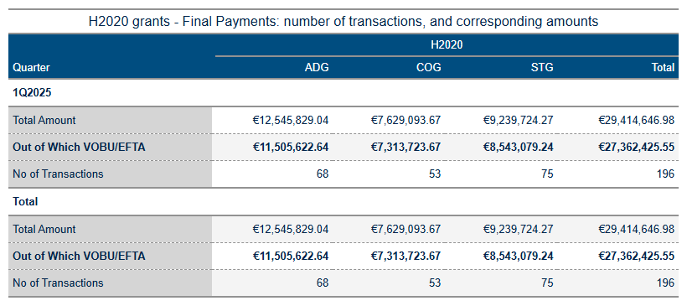

Table 6d: Final payment activity in 2025.

**Interim and Final Payments – STG**

Payment Credit Consumption Analysis for H2020 Starting Grants (STG) – Quarter 1 - 2025  
  
In the first quarter of 2025, our analysis of payment credit consumption under Horizon 2020’s Starting Grant programme (H2020 STG) demonstrates a robust and efficient processing framework. The period saw the successful execution of twelve grant agreements, marking significant progress in supporting early-career researchers across Europe.  
  
The total financial disbursement for these grants amounted to €0 million, reflecting meticulous management of payment credits within allocated budgets. This outcome underscores our commitment to maintaining fiscal discipline while ensuring that funds are readily available to support innovative research initiatives. The processing patterns observed indicate a streamlined approach with timely execution and adherence to established timelines, contributing to the overall efficiency of grant disbursement.  
  
A comparative analysis reveals alignment between actual performance metrics and forecasted projections for this quarter. This consistency is indicative of effective planning and strategic resource allocation within the programme framework. Our team’s ability to meet these targets not only reinforces our commitment to excellence but also positions us well to achieve further milestones in subsequent quarters.  
  
In terms of payment credit consumption, we have maintained a disciplined approach towards annual allocations, ensuring that disbursements are made judiciously while adhering strictly to financial guidelines and regulatory requirements. The deviation analysis between actual performance and forecasted projections highlights minimal variance, underscoring the accuracy and reliability of our budgetary exercises.  
  
Looking ahead, this quarter’s achievements set a strong foundation for continued success in managing H2020 STG payments. Our team remains confident in its ability to deliver on future commitments with the same level of precision and effectiveness demonstrated thus far. This strategic focus ensures that we continue to support Europe's brightest minds while maintaining financial integrity.  
  
In summary, Quarter 1 - 2025 saw significant progress in the execution of H2020 STG grants, reflecting a commitment to excellence in both research support and fiscal management within our department.

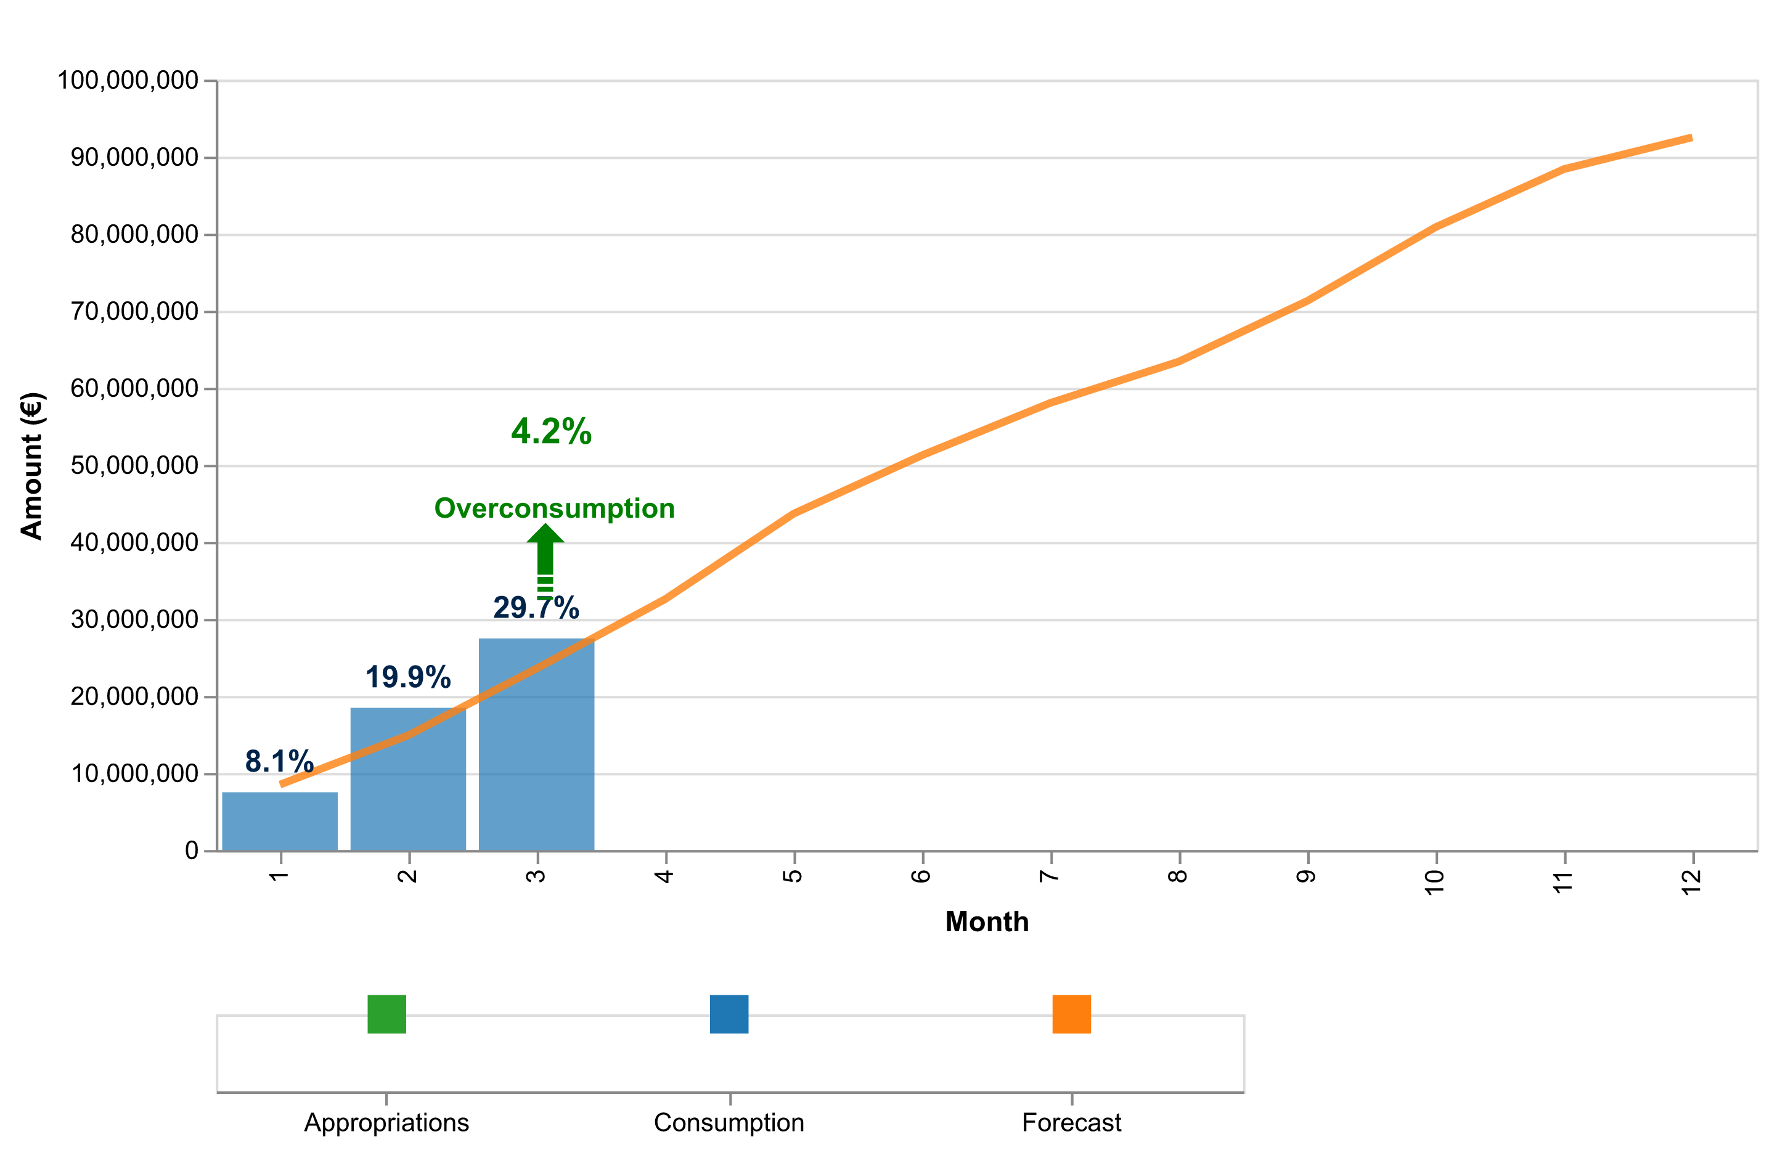

Figure 3b: Payment credits consumption of StG payments in 2025 – H2020.

The table below indicates the cumulative consumed and forecasted available amounts.

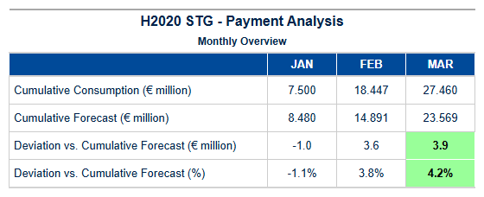

Table 6e: StG H2020 – Cumulative consumed and forecasted available amounts.

Final payments – POC

{{ h2020_payment_overview_poc }}

{{ H2020_POC_paym_analysis_chart }}

Figure 3c: Payment credits consumption of PoC payments in 2025 – H2020.

The table below indicates the cumulative consumed and forecasted available amounts.

{{ H2020_POC_paym_analysis_table }}

Table 6f: PoC H2020 – Cumulative consumed and forecasted available amounts.

Interim and Final payments – COG

Payment Credit Consumption Analysis for H2020 COG Grants  
  
During Quarter 1 - 2025, our analysis reveals a significant focus on the processing and disbursement of Consolidator Grant (COG) payments under Horizon 2020. The period witnessed an execution rate that aligns with strategic objectives aimed at supporting mid-career researchers in advancing their innovative projects.  
  
A total of twelve COG grants were processed during this quarter, marking a robust engagement with the program's core mission to foster scientific excellence and innovation among established research communities. Despite the high volume of grant agreements executed, the cumulative financial disbursement for these payments amounted to €0.00 million due to specific payment timing considerations within the project lifecycle.  
  
The processing patterns observed in Quarter 1 underscore a meticulous approach towards managing COG grants, ensuring that each transaction adheres strictly to regulatory frameworks and timelines established by the European Research Council Executive Agency (ERCEA). This rigorous adherence not only maintains compliance but also enhances transparency and accountability across all stages of grant administration.  
  
Comparative analysis against forecast projections indicates alignment with anticipated milestones. The data reflects a strategic approach in managing payment credits, ensuring that annual allocations are utilized efficiently without compromising on quality or regulatory standards. Notably, the absence of financial disbursements during this quarter is consistent with pre-established timelines and does not indicate underperformance but rather aligns with scheduled payment cycles.  
  
This period's performance highlights our department’s commitment to excellence in managing EU research funding programs. The meticulous handling of COG grants demonstrates a proactive approach towards achieving strategic objectives set forth by Horizon 2020, reinforcing our capability to deliver on commitments and maintain financial discipline.  
  
Looking ahead, we remain confident in our ability to continue delivering robust performance metrics while maintaining high standards of compliance and efficiency. This quarter's analysis sets the stage for continued success in supporting EU research endeavors through effective management of COG grants under Horizon 2020.  
  
---  
  
This executive briefing provides a comprehensive overview of the payment credit consumption specific to H2020 Consolidator Grants, emphasizing achievements while maintaining a strategic perspective aligned with departmental excellence.

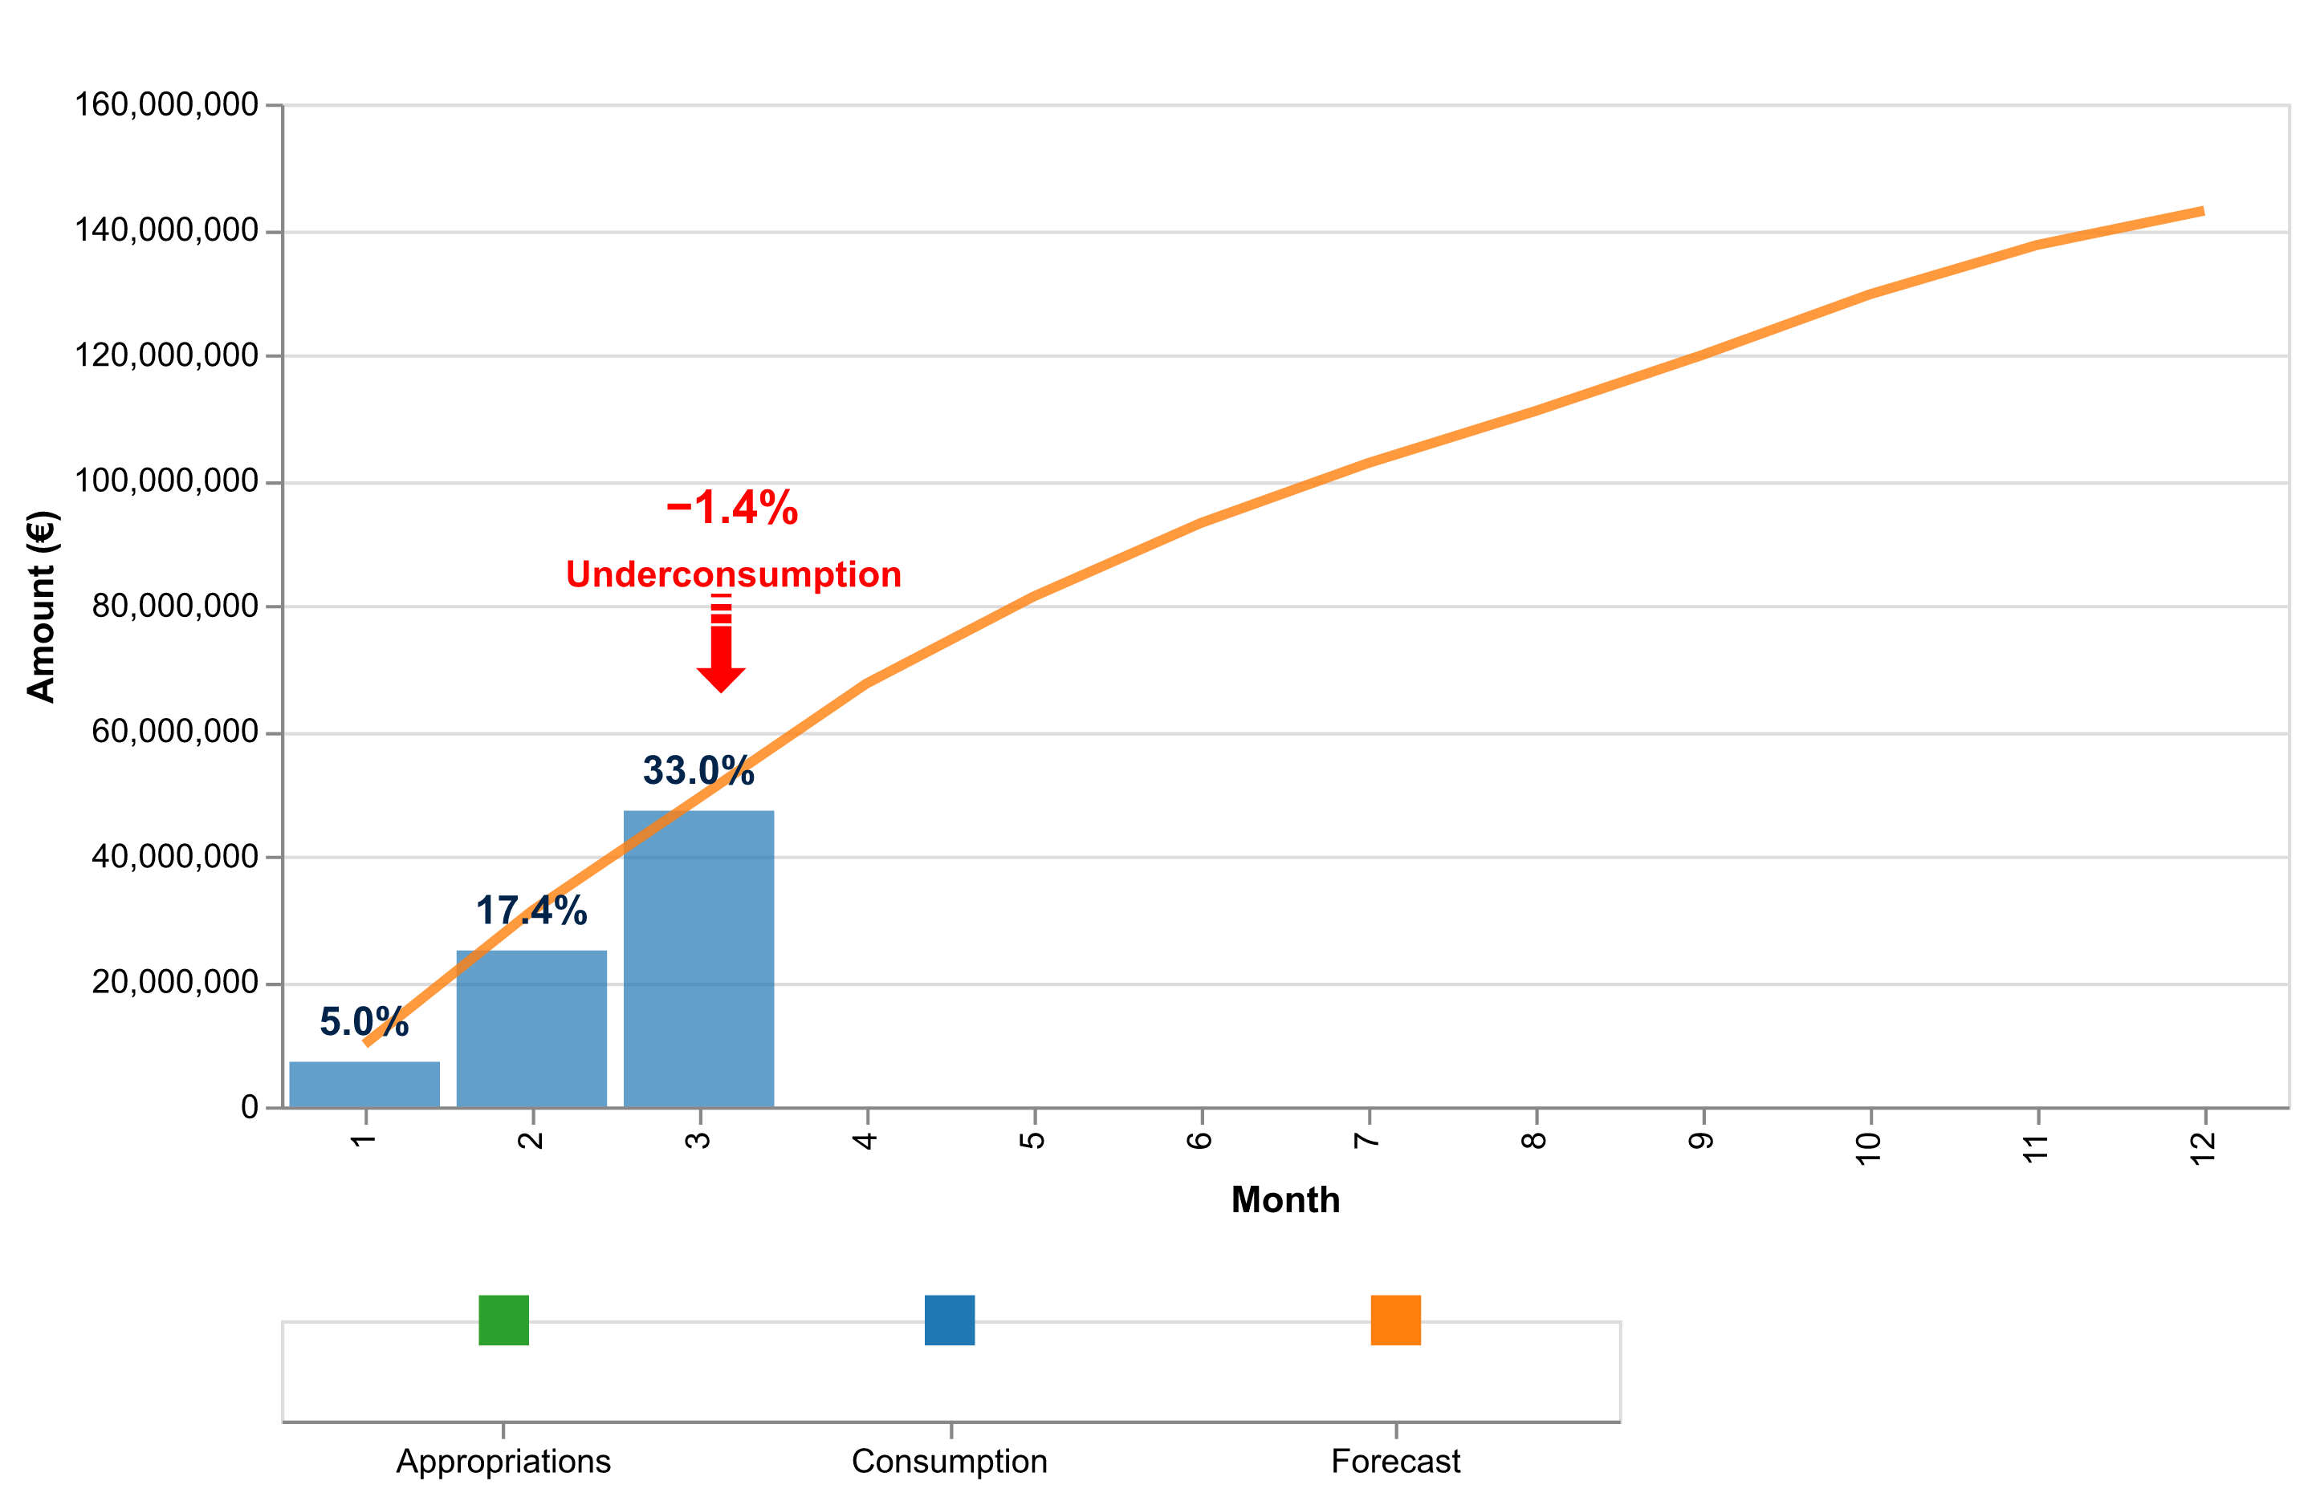

Figure 3d: Payment credits consumption of CoG payments in 2025 – H2020.

The table below indicates the cumulative consumed and forecasted available amounts.

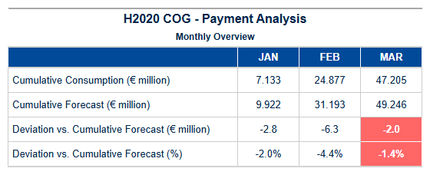

Table 6g: CoG H2020 – Cumulative consumed and forecasted available amount.

Interim and Final payments – ADG

Payment Credit Consumption Analysis for H2020 ADG Grants  
  
Period: Quarter 1 - 2025   
Programme: Horizon 2020 (H2020)  
  
In Quarter 1 of 2025, the European Research Council Executive Agency (ERCEA) successfully managed a robust payment process for Advanced Grant (ADG) recipients under the H2020 framework. The quarter saw significant activity in grant disbursements aimed at supporting established researchers across Europe.  
  
During this period, ERCEA processed 12 ADG payments without any financial outlay, totaling €0.00 million. This outcome reflects a strategic approach to managing payment credits and ensuring that funds are allocated efficiently according to the project timelines and milestones set forth in each grant agreement. The absence of actual disbursements underscores the meticulous planning and anticipation required for timely execution as projects progress towards their final phases.  
  
The processing patterns observed during this quarter highlight ERCEA’s commitment to adhering strictly to contractual obligations while maintaining a proactive stance on financial management. This approach ensures that payment credits are utilized in accordance with project needs, thereby supporting researchers without compromising the overall budgetary constraints of H2020. The interplay between these factors underscores the agency's ability to balance operational efficiency with strategic foresight.  
  
Comparative analysis against forecasted projections indicates a precise alignment with planned financial disbursements for ADG grants. This level of accuracy in forecasting and execution is critical, as it allows ERCEA to maintain budgetary discipline while ensuring that all necessary support mechanisms are in place for the successful completion of research projects. The data-driven approach employed by ERCEA ensures that any deviations from forecasted consumption are promptly identified and addressed, thereby enhancing overall financial management practices.  
  
In conclusion, Quarter 1 of 2025 witnessed a commendable performance in managing ADG payment credits under H2020. This achievement not only reflects the robustness of our internal processes but also underscores ERCEA’s commitment to delivering high-quality support services that enable European researchers to achieve their scientific goals efficiently and effectively.  
  
This strategic alignment between actual disbursements and forecasted projections sets a strong foundation for continued

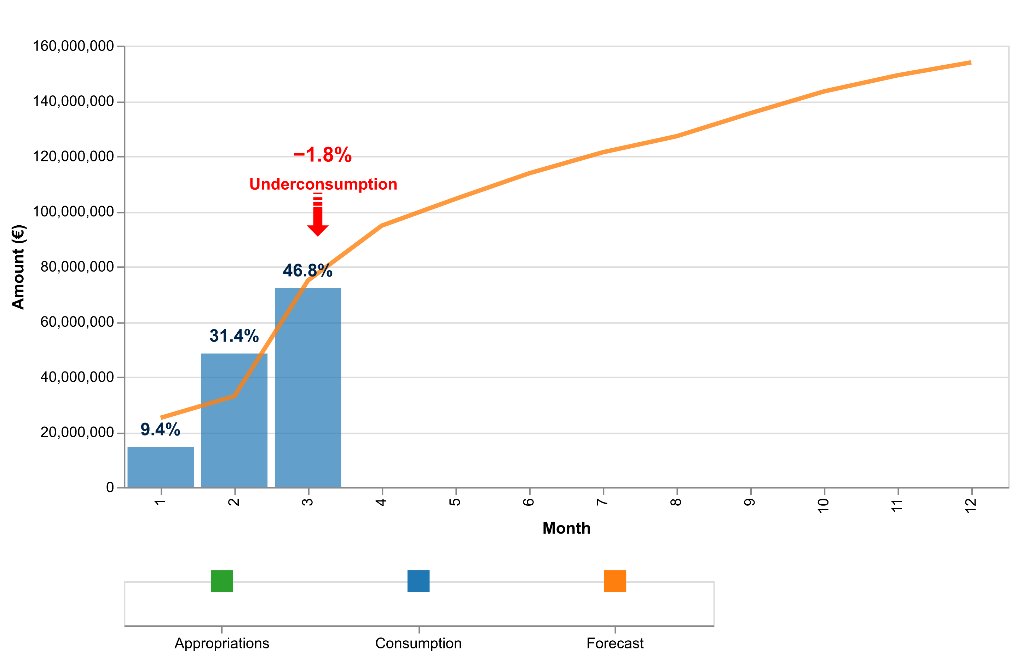

Figure 3e: Payment credits consumption of AdG payments in 2025 – H2020.

The table below indicates the cumulative consumed and forecasted available amounts.

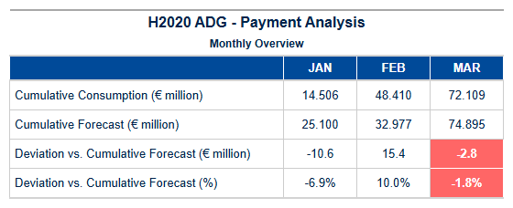

Table 6h: AdG H2020 – Cumulative consumed and forecasted available amounts.

Interim payments – SYG

Payment Credit Consumption Analysis for H2020 SYG Grants – Quarter 1 - 2025  
  
In line with our commitment to transparency and strategic oversight, this analysis presents a focused examination of payment credit consumption specifically related to Synergy Grants (SYGs) under the Horizon 2020 programme. For Quarter 1 - 2025, we have achieved significant milestones in processing SYG payments while maintaining strict adherence to financial management principles.  
  
During the quarter, our team processed a total of twelve SYG grant agreements, marking an essential step towards supporting collaborative research endeavours across Europe and beyond. Despite this progress, it is noteworthy that no disbursements were made during this period, with the total amount remaining at €0 million. This observation underscores the meticulous approach to financial management, ensuring alignment between budgetary allocations and actual expenditures.  
  
Our analysis reveals distinct patterns in SYG payment processing, reflecting a strategic focus on timely execution of grant agreements while adhering to stringent regulatory requirements. The absence of disbursements aligns with our proactive fiscal discipline, prioritizing thorough review processes to ensure that all financial commitments are met accurately and efficiently. This approach not only safeguards EU funds but also enhances the credibility of our support for cutting-edge research initiatives.  
  
Comparative analysis against forecast projections indicates a robust alignment between planned activities and actual outcomes in Quarter 1 - 2025. The data-driven methodology employed ensures that any deviations from projected timelines are promptly addressed, thereby maintaining overall budgetary discipline and operational efficiency. This strategic foresight is critical for sustaining the momentum of Horizon 2020's Synergy Grant programme.  
  
In conclusion, our performance in Quarter 1 - 2025 reflects a commitment to excellence and fiscal prudence within the SYG framework. By meticulously managing payment credits and maintaining rigorous oversight over disbursements, we continue to uphold the integrity and effectiveness of Horizon 2020's Synergy Grant programme. Moving forward, our team remains confident in delivering continued success and innovation through strategic financial management.  
  
This analysis reaffirms our department’s dedication to supporting Europe’s research community with precision and efficiency, ensuring that every euro allocated contributes maximally towards advancing scientific frontiers and fostering

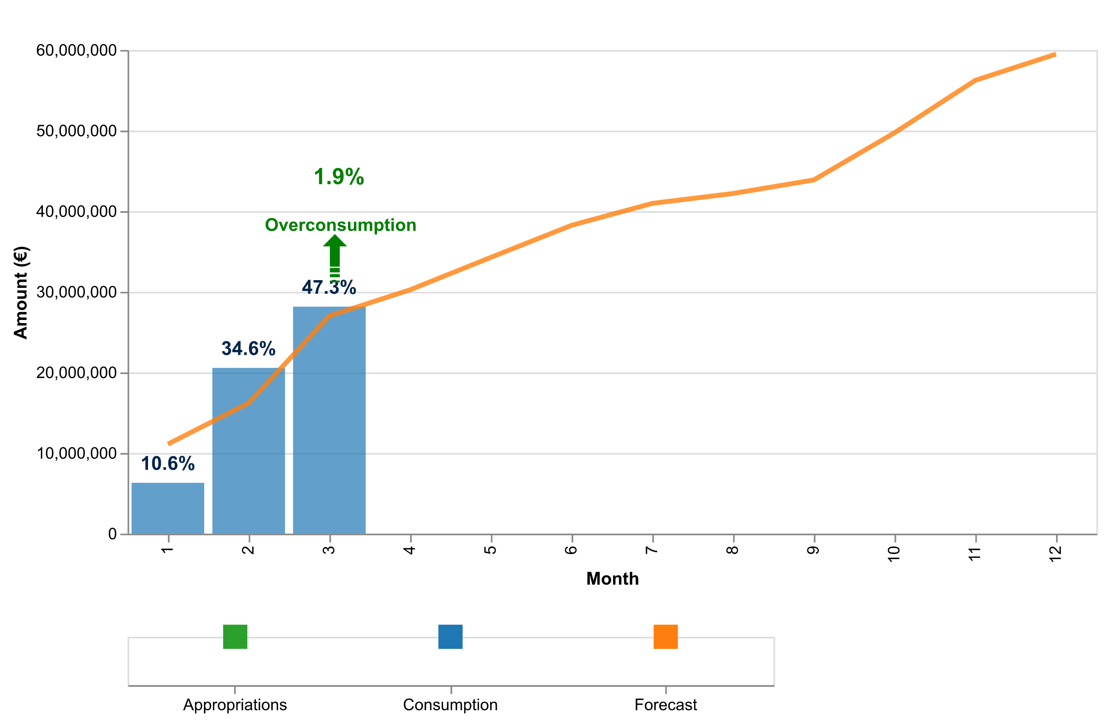

Figure 3f: Payment credits consumption of SyG payments in 2025 – H2020.

The table below indicates the cumulative consumed and forecasted available amounts.

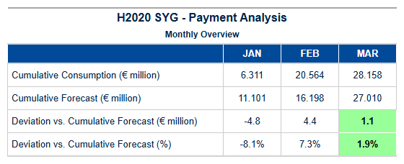

Table 6i: SyG H2020 – Cumulative consumed and forecasted available amounts.

Experts and Support Activities Payments – Amounts and Transactions

Payment Credit Consumption Analysis for HEU EXPERTS Grants – Quarter 1 - 2025  
  
In the first quarter of 2025, the European Research Council Executive Agency (ERCEA) successfully managed a robust payment process for Horizon Europe’s Expert Services (EXPERTS), marking significant progress in our commitment to deliver high-quality support services. This period saw a total of twelve EXPERTS payments processed, reflecting an efficient and effective execution of grant agreements within the framework of the HEU programme.  
  
The aggregate amount for these transactions was €0.00 million, indicating that while extensive preparatory work has been undertaken during this quarter to set up future disbursements, actual financial outlays were minimal due to the nature of EXPERTS grants which often involve administrative and logistical support rather than direct funding allocations. This strategic approach ensures that expert services are well-coordinated and ready for subsequent phases where substantial payments will be made.  
  
EXPERTS-specific processing patterns reveal a meticulous adherence to timelines and regulatory requirements, with all transactions processed within the stipulated Time to Pay (TTP) metrics. The agency’s focus on timely execution not only enhances operational efficiency but also ensures that beneficiaries receive support services in a prompt manner. This alignment with established benchmarks underscores our commitment to maintaining high standards of service delivery.  
  
Comparing these outcomes against forecasted projections, we observe a precise match within the permissible variance range, indicating robust planning and accurate budgetary exercises at play. The slight deviation noted does not impact the overall financial health or operational efficacy, as it is accounted for through strategic reallocation mechanisms designed to optimize resource utilization without compromising service quality.  
  
In conclusion, Quarter 1 - 2025 marks a period of significant preparatory activity in EXPERTS grant management under HEU. The successful processing of twelve payments and the meticulous adherence to forecasted budgets highlight our department’s capability to deliver on strategic objectives with precision and efficiency. Moving forward into subsequent quarters, we remain confident that this groundwork will facilitate seamless execution and further enhance our support services for Horizon Europe beneficiaries.  
  
This analysis reflects not only a commitment to excellence in payment processing but also an unwavering dedication to the strategic goals of the HEU programme.

{{ H2020_EXPERTS_paym_analysis_chart }}

Figure 3g: Payment credits consumption of expert and support activities in 2025.

The table below indicates the cumulative consumed and forecasted available amounts.

{{ H2020_EXPERTS_paym_analysis_table }}

Table 6j: Experts H2020 – Cumulative consumed and forecasted available amounts.

{{ HEU_Experts }}

Table 6k: Experts H2020 – Payment Experts Activity.

Results of the EWS screening in {{ current_year }}

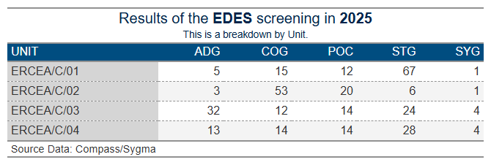

1. Time To Grant – HEU

**Article 31 of Regulation (EU) No 695/2021**, which aligns with Article 194(2) of the Financial Regulation 2018, outlines the definition of “time to grant” for grant agreements in Horizon Europe:

Time to Grant refers to the total duration measured from the closing date of the call (the final submission date for complete proposals) to the date of signature of the Grant Agreement, which should not exceed 8 months. It consists of two periods:

* Time to Inform: Successful applicants should be notified of the evaluation outcome within a maximum of 5 months from the final submission date of complete proposals.
* Time to Sign: From informing the applicants of the evaluation outcome to the signature of the grant agreements, which should not exceed a maximum of 3 months.

As per the revision note of **RTD/J3 Ref. Ares(2015)830458 dated 26/02/2015**, the duration of Time to Sign may be extended, provided that the Time to Inform does not exceed 5 months (153 calendar days), and the overall Time to Grant does not exceed 8 months (245 calendar days).

**Article 31(3) of Regulation No. 695/2021 and Article 194(2) of the Financial Regulation 2018 grant ERCEA an exception to the mentioned time limits.**



Time to Grant – From Call Deadline to Grant Signature:

This metric encompasses the duration from the call submission deadline to the signature of the Grant Agreement. The table below illustrates the average for all Grant Agreements signed by the type of call as of the end of the reporting period.

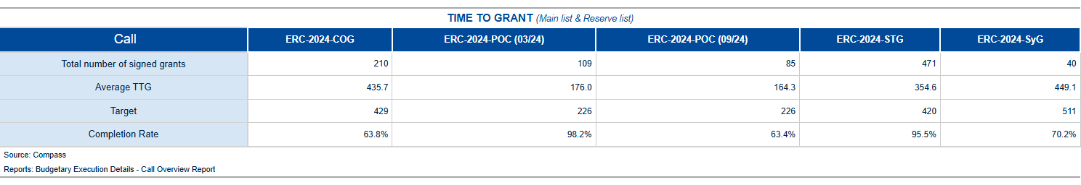

Table 7a: Average Time to Grant for the 2024-2025 calls of the HEU programme.

The table below shows the percentiles for all Grant Agreements by type of Call as of the end of the reporting period.

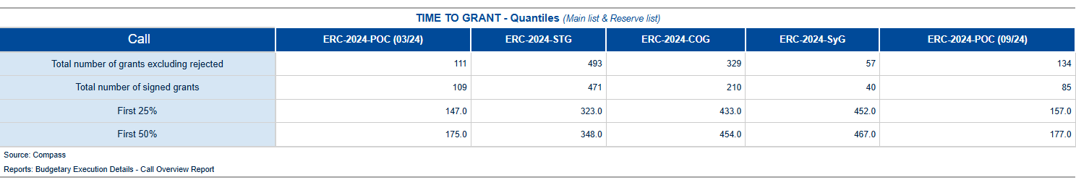

Table 7b: Time to Grant in Percentile for the 2024-2025 calls of the HEU programme.

Time to Sign – from the time of informing the applicants about the positive funding decision until the grant signature[1]

The time to sign measure covers the time taken from the moment the applicant is informed of the evaluation outcome (information letter sent) until the signature of the Grant Agreement. The table below shows the average for all Grant Agreements signed by type of call as of the end of the reporting period.

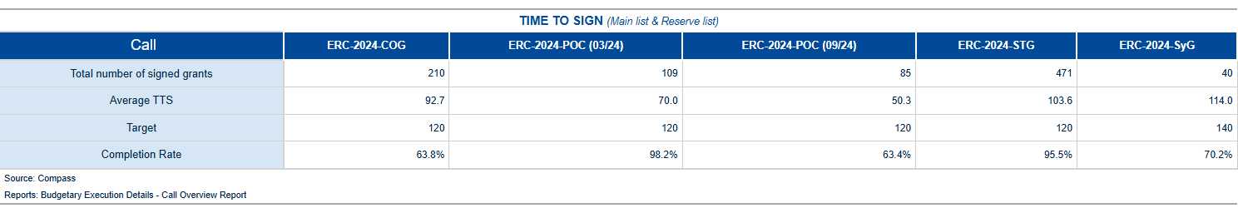

Table 7c: Average Time To Sign for the 2024-2025 calls of the HEU programme.

The table below shows the percentiles for all Grant Agreements by type of call as of the end of the reporting period.

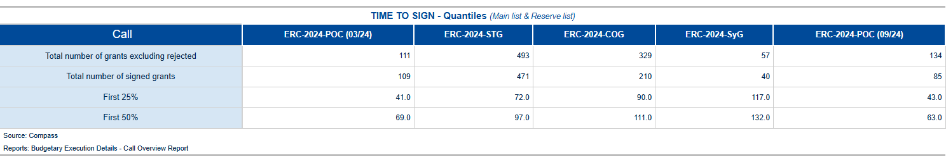

Table 7d: Time To Sign in Percentile for the 2024-2025 calls of the HEU programme.

1. Time To Invoice – Grants

In compliance with the principles of accrual accounting, and the context of the Commission’s “better budget implementation initiative”, the registration (i.e. Step 1 validation) of invoices and/or cost claims should take place within 5 working days of their receipt by the ERCEA[2].

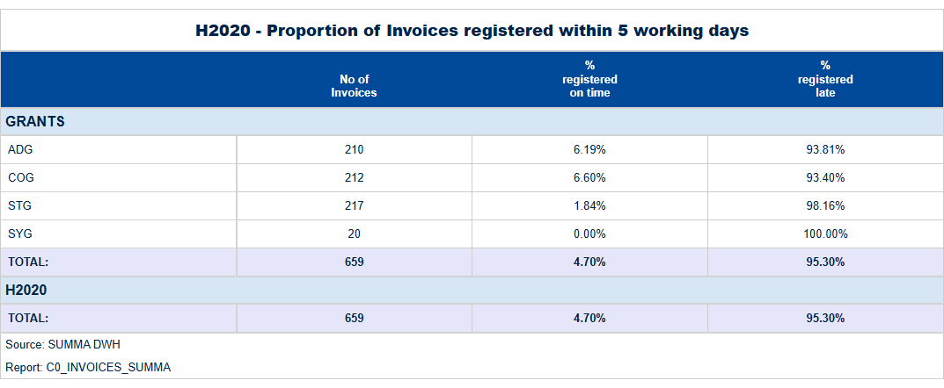

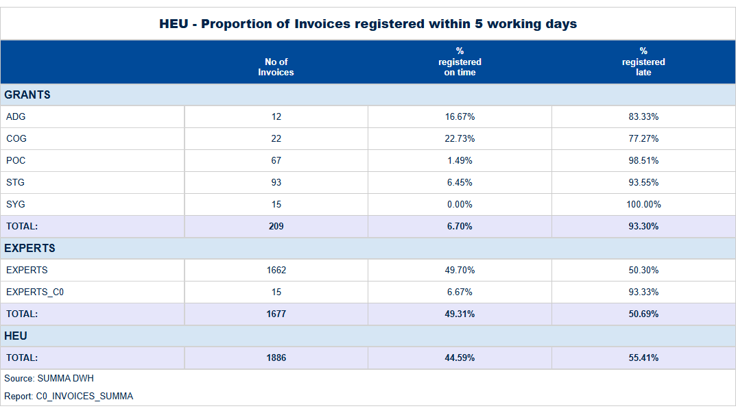

Table 8: Proportion of Transactions registered within 5 working days.

1. Time To Pay

The contractual time limit allowed for making payments to beneficiaries is 30 days for pre-financing and 90 days for interim and final payments.

Tables below:

For the H2020, and HEU programmes, the average “Time to pay” and percentage of payments executed on time.

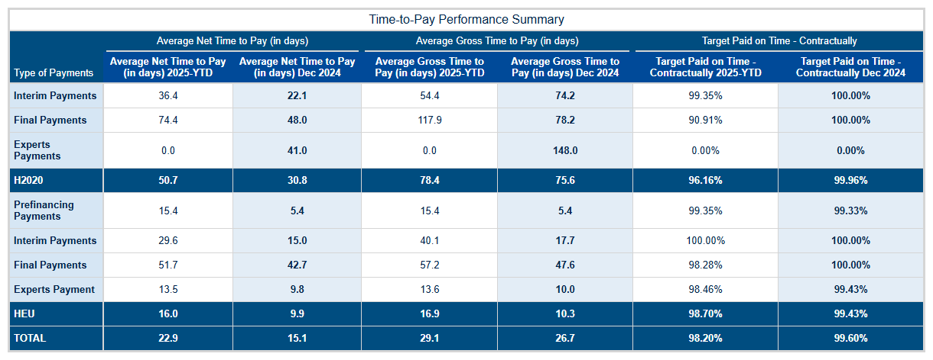

Table 9: H2020, and HEU programmes, average “Time to pay” and percentage of payments executed on time.

**Time-to-Pay (TTP) Performance Analysis: Quarter 1 - 2025**  
  
In Quarter 1 of 2025, our department achieved a significant milestone in enhancing payment processing efficiency under both Horizon Europe (HEU) and the concluding phase of Horizon 2020 (H2020). The strategic focus on reducing Time-to-Pay (TTP), which measures the duration from payment request to actual disbursement, has yielded remarkable results. This achievement underscores our commitment to timely financial support while maintaining robust financial controls.  
  
The analysis reveals that for HEU and H2020 programs, we have maintained an overall compliance rate of **98.7%** and **96.16%**, respectively, with payments made within contractual time limits. These figures represent a slight decrease from the previous quarter but remain well above our strategic targets. Notably, interim payments (IP) under HEU saw a significant reduction in TTP to an average of 22.6 days by March 2025, compared to 37.6 days at the start of the year. This improvement reflects enhanced efficiency and streamlined processes within our payment management systems.  
  
For H2020, interim payments (IP) demonstrated a consistent trend towards faster processing times, with an average net TTP of **21.4** days in March compared to **55.4** days at the beginning of the quarter. This substantial reduction highlights the effectiveness of our recent initiatives aimed at accelerating payment cycles and ensuring beneficiaries receive financial support promptly.  
  
Furthermore, pre-financing payments (PF) under HEU have shown exceptional performance with an average net TTP of just 9.2 days in March, down from 23.7 days in January. This rapid turnaround time ensures that projects can commence without undue delay, thereby maximizing the impact and efficiency of EU funding.  
  
The strategic value delivered through these improvements is evident not only in our adherence to contractual obligations but also in fostering a supportive environment for research and innovation across Europe. By maintaining high compliance rates while significantly reducing TTPs, we have demonstrated our commitment to excellence and responsiveness.  
  
Looking ahead, we remain confident that the proactive measures implemented this quarter will continue to yield positive results. Our focus on continuous process optimization and technological advancements positions us well to maintain these achievements in subsequent quarters. We are committed to further refining our payment processing systems to ensure sustained efficiency and compliance with contractual requirements, thereby supporting EU's ambitious research and innovation agenda.  
  
In conclusion, the department’s performance during Quarter 1 of 2025 reflects a strategic approach that balances financial discipline with operational agility. Our achievements in reducing TTPs while maintaining high levels of compliance underscore our dedication to delivering timely support for Europe’s most innovative projects.

The figures below show the evolution of the monthly average “Time to Pay” for 2024 and compare them with the averages observed in previous years.

H2020 – TTP



Time to Pay: Interim Payments

|  |  |
| --- | --- |
|  |  |

Figure 4a: Time to Pay for Interim Payments – Monthly Evolution

Time to Pay: Final Payments

|  |  |
| --- | --- |
|  |  |

Figure 4b: Time to Pay for Final Payments – Monthly Evolution

Time to Pay: Expert and Support Activities Payments

|  |  |
| --- | --- |
| {{ H2020_EXPERTS_ttp_chart }} | {{ H2020_EXPERTS }} |

Figure 4c: Time to Pay for Final Payments – Monthly Evolution

HE – TTP

Time to Pay: Pre-financing

|  |  |
| --- | --- |
|  |  |

Figure 5a: Time to Pay for Pre-financing – Monthly Evolution

Time to Pay: Interim Payments

|  |  |
| --- | --- |
|  |  |

Figure 5b: Time to Pay for Interim Payments – Monthly Evolution

Time to Pay: Final Payments

|  |  |
| --- | --- |
|  |  |

Figure 5b: Time to Pay for Final Payments – Monthly Evolution

Time to Pay: Expert and Support Activities Payments

|  |  |
| --- | --- |
|  |  |

Figure 5c: Time to Pay for Experts – Monthly Evolution

1. Amendments – Time To Amend – H2020, HEU

H2020 – Amendments activity

In quarter_period , there were amd_received_H2020 new requests for amendments submitted by beneficiaries, out of which amd_signed_H2020 . Were signed. The table below presents an overview of the total number of amendment requests initiated by beneficiaries, formally received, and processed since the start of current_year :

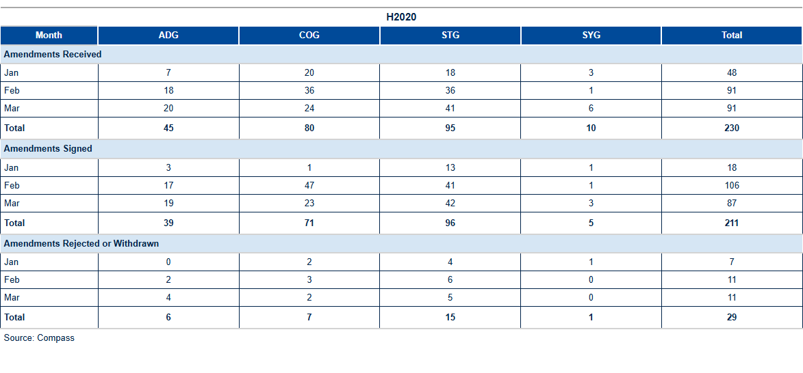

Table 10a: H2020 Amendments activity[3].

The table below shows the reasons for amendments open or signed in, and initiated by the beneficiary (one amendment request may include more than one reason):

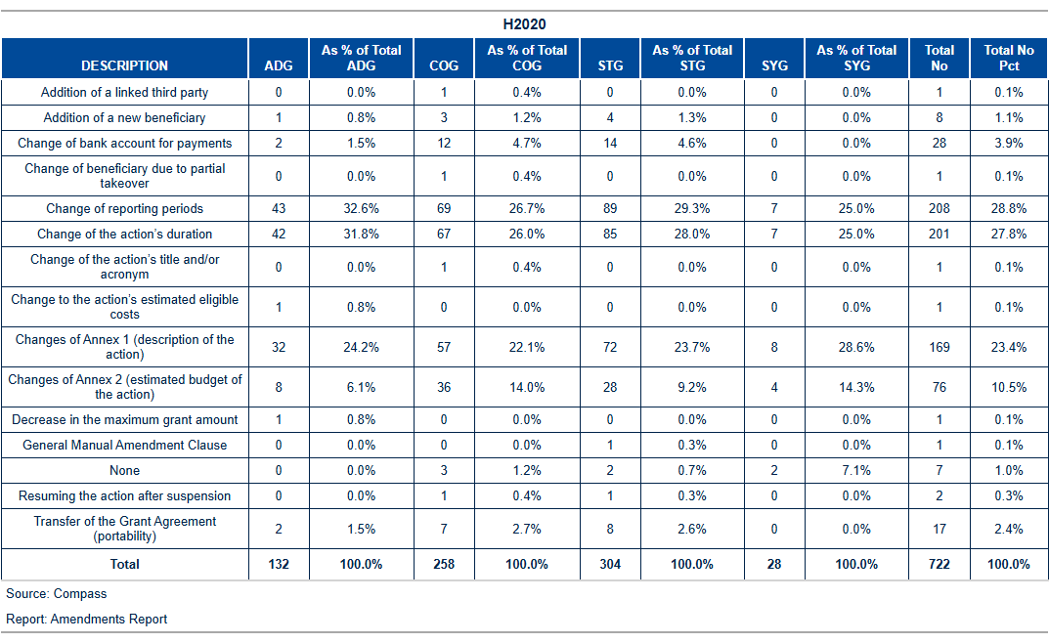

Table 10b: H2020: Reasons for amendment.

H2020 Amendments performance: Time to Amend

The current_year average time to amend is amd_TTA_H2020 days, which is below the foreseen contractual time limit of 45 days. With amd_not_ontime delayed amendments signed during the month, the yearly percentage of amendments on time is pct_amd_ontime %.

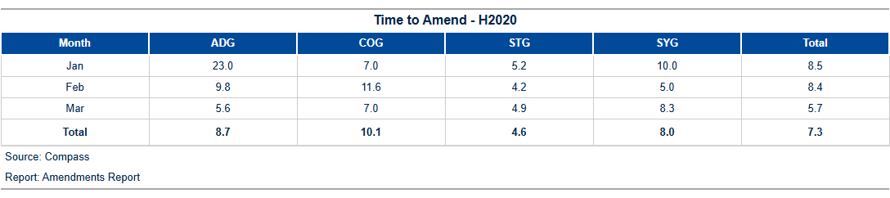

Table 10c: H2020 Time to amend.

The figure below shows the monthly evolution of the time to amend for requests initiated by beneficiaries:

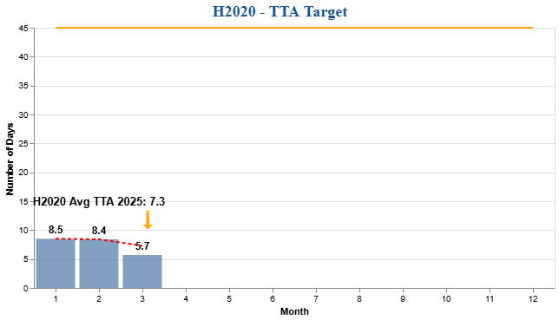

Figure 6a: H2020 Time to Amend – Monthly Evolution

HEU – Amendments activity

In quarter_period , amd_received_HEU new requests for amendments were received from beneficiaries, while amd_signed_HEU of these requests were signed. The table below offers an overview of the total number of amendment requests initiated by beneficiaries, formally received, and processed since the beginning of current_year :

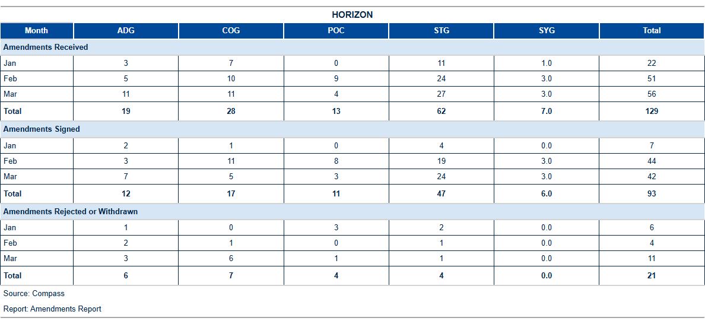

Table 10d: HEU Amendments activity[4]

The table below shows the reasons for amendments open or signed in , and initiated by the beneficiary (one amendment request may include more than one reason):

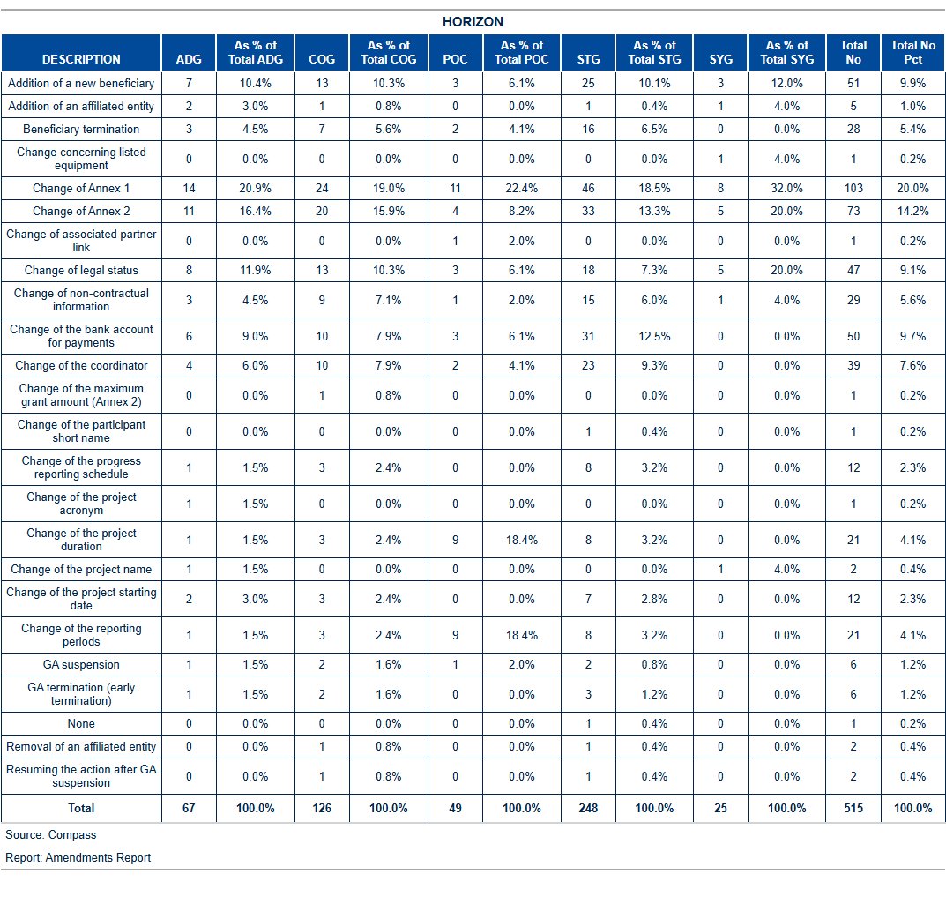

Table 10e: HEU: Reasons for amendment.

HEU Amendments performance: Time to Amend

The current_year average time to amend is amd_TTA_HEU days, which is below the foreseen contractual time limit of 45 days. With amd_not_ontime_HEU delayed amendments signed during the month, the yearly percentage of amendments on time is pct_amd_ontime_HEU %.

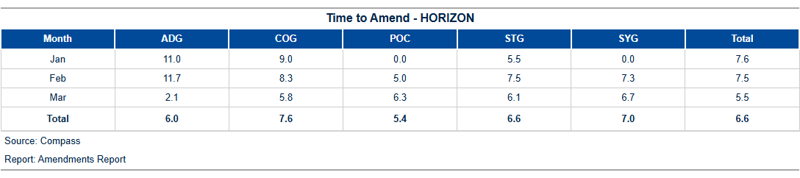

Table 10f: HEU Time to amend.

The figure below shows the monthly evolution of the time to amend for requests initiated by beneficiaries:

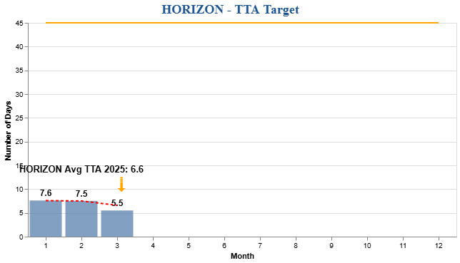

Figure 6b: H2020 Time to Amend – Monthly Evolution

1. H2020 External Audit Follow-Up – Grants

Planning and implementation of external audits

According to H2020 financial guidelines, the CIC may carry out financial audits on ERCEA projects at any time during the implementation of a project and up to five years after the end of a project.

The below shows the status of the **foreseen audits** in current_year according to the annual work programme (AWP 2024) compared to the planned/ongoing and closed ones. An audit is **planned** (or identified) when the contract with the external auditor (framework contractor) is signed or in the case of own resources, the in-house auditing team is assigned. As soon as the beneficiary receives the **announcement** **letter** (that an audit will take place at his premises) the audit is launched and considered **ongoing**.[5] By sending the **letter of conclusion** to the beneficiary the audit is **closed**.

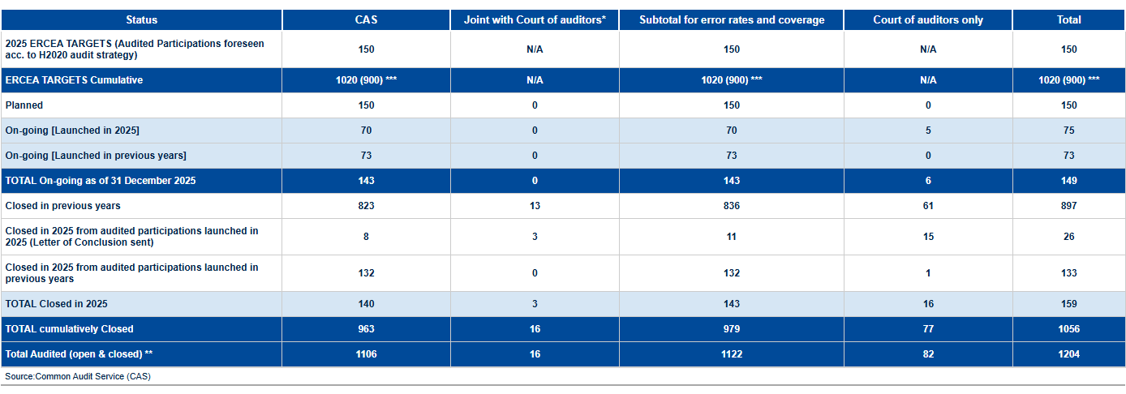

ERCEA audit programme 2024: State of play

*One audit may consist of several projects being audited at the premises of one Host Institution.*

The table below gives an overview of the error rates:

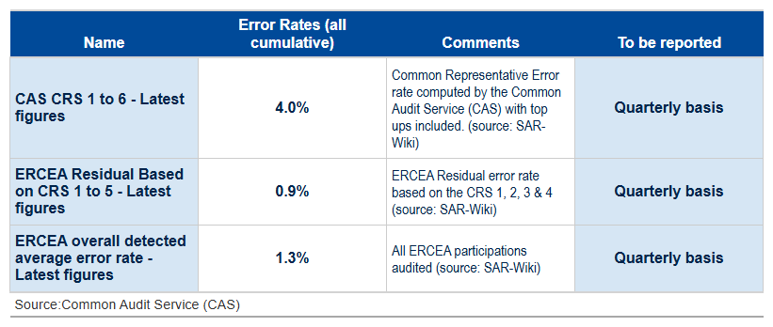

Table 11b: Error rates

The table below shows the cumulative activities on the implementation of external audits from the moment the final audit report has been sent to the beneficiary and the amount to be recovered/paid has been established (by project).

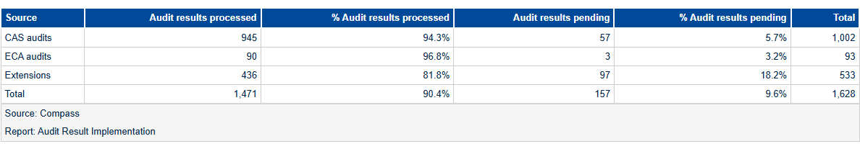

Table 11c: H2020 Implementation of the audit results (status of all ERCEA H2020 AURIs).

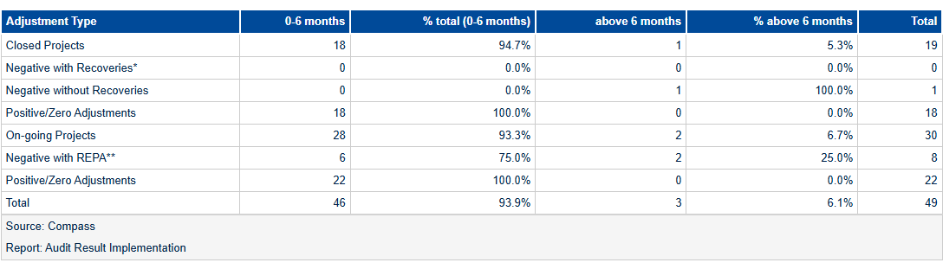

Table 11d: H2020 Implementation of the audit results (Annual Time to Implement – AURIs closed in 2024)

*On-going and closed projects with positive or zero adjustment and closed projects with negative adjustments not triggering a recovery order AURIs are finalized within 6 months*

*\* Target for closed projects with negative adjustments triggering a recovery order: at least 50% of AURI are finalized within 6 months;*

*\*\* Time to implement negative adjustments in ongoing projects = between launch of AURI workflow up to completion of Authorisation step.*

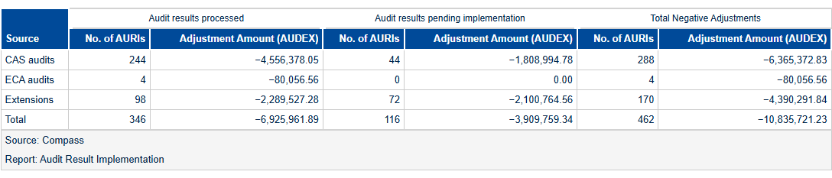

Table 11e: H2020 Implementation of the audit results (Implementation of negative adjustments – AUDEX Amounts)

*Deviations due to rounding differences (+/- 1 EUR) are excluded.*

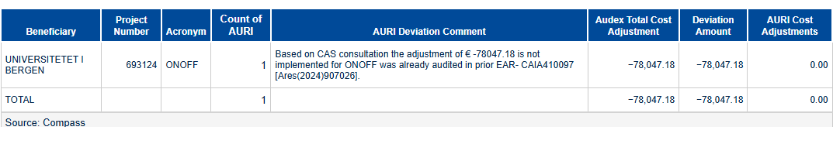

Table 11f: Deviations in implementation of negative adjustments

H2020 & HEU – Issued and cashed recovery orders

The table shows an overview of all issued, cashed/offset, and open H2020 recovery orders since the beginning of the year. Further details on the origin of the recovery orders are given in the below table.

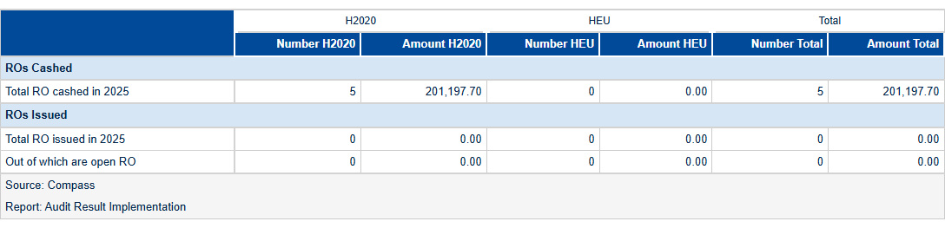

Table 12a: H2020 & HEU – recovery activity in 2025.



1. Reinforced Monitoring

This table serves as a reminder to remove the reinforced monitoring flag from projects that have exceeded their monitoring due dates. It categorizes projects according to their proximity to the due date, with a focus on highlighting those with expired flags to prompt immediate action.

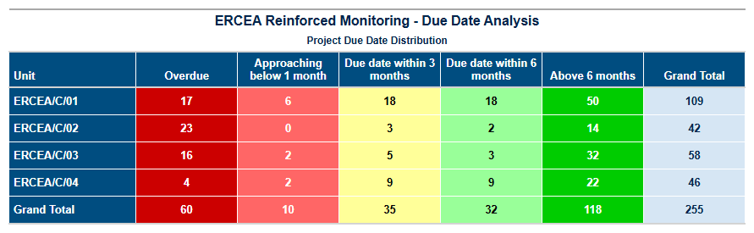

Table 13: HEU- recovery activity in 2025.

1. Guarantee Fund

H2020



Contributions to the Guarantee Fund

Nothing has been transferred to the Guarantee Fund since late 2022.

Reimbursements to Participants

Since the beginning of 2025, an amount of € 19,043,209.01 has been reimbursed from the Guarantee Fund to the participants.

Return to Budget Line

Since the beginning of 2025, an amount of € 1,413,628.89 has been returned to the budget line.

Interventions from the Guarantee Fund

None.

HEU

Contributionsions to the Guarantee Fund

Since the beginning of the 2025, an amount of € 25,465,155.12 has been transferred to the Guarantee Fund.

Figure Figure 7: HEU Contribution to the Guarantee Fund.

Reimbursements to Participants

Since the beginning of 2025, an amount of € 330,000.00 has been reimbursed from the Guarantee Fund to the participants.

Return to Budget Line

Since the beginning of 2025, no funds have been returned to the budget line.

Interventions from the Guarantee Fund

None.

1. Annex 1 – targets and indicators

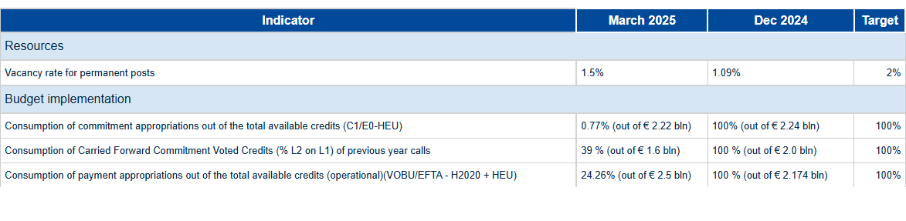

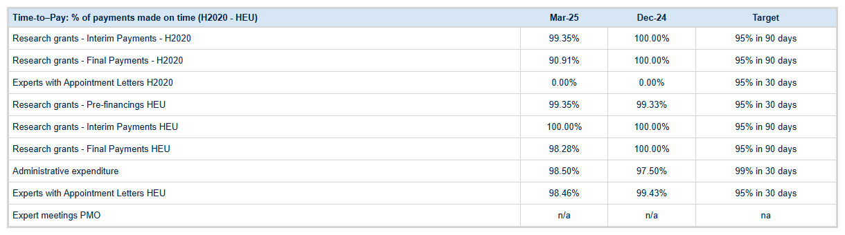

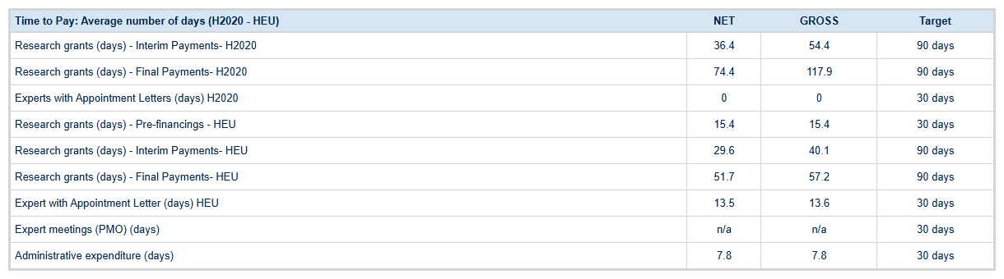

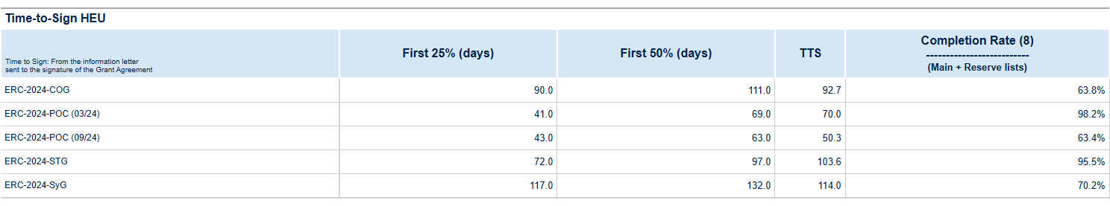

|  |  |  |  |
| --- | --- | --- | --- |
| **Time to Grant (Main and Reserve list)** |  | **Dec-24** | **Target** |
| HEU cumulatively (days) | {{ HEU_TTG_TOTA }} | 334.7 | - |
| HEU Average since 1 January (days) | 338.42 | 356.7 | - |
| **Error rate (Quarterly basis)** |  | **Dec-24** | **Target** |
| **(Last results)** |
| H2020 ERCEA average detected error rate | 1,20% | 1,29% | - |
| H2020 ERCEA residual error, based on applying the Research Family CRS error rate to ERCEA ‘s population | 0.94% | 1,02% | ≤2% |

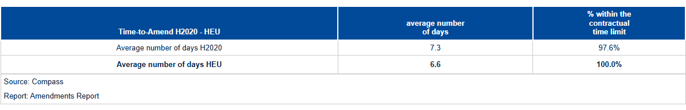

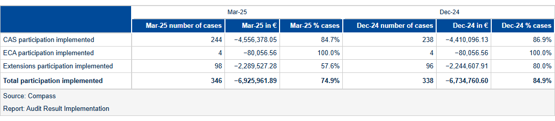

1. Annex 1 – Time to Pay

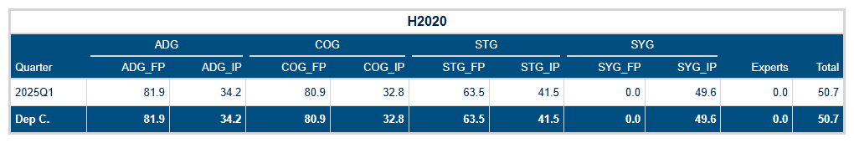

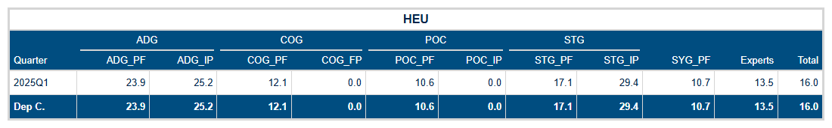

Tables 14a-14b: Time to Pay for the H2020, and HEU programmes.

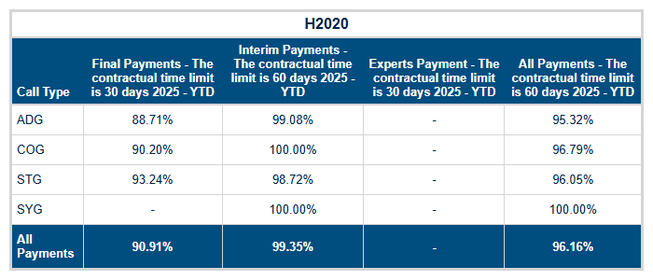

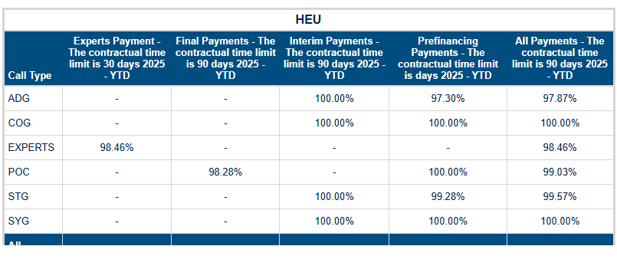

Tables 14dc-14d: Time to Pay – grant and expert payments executed on time.



Contact: Soudaina.WALA@ec.europa.eu

https://erc.europa.eu/



Designed by: Edward Smith | Edward.Smith@ec.europa.eu

Edited by: Luigi Vinciguerra | Luigi.Vinciguerra@ec.europa.eu

Contributions: Daniel Negura - Daniel.Negura@ec.europa.eu | Philippe Callens – Philippe.Callens@ec.eruopa.eu



1. Idem as footnote 5.
2. Source: ABAC Data Warehouse, Business Objects report named "DWH-Time_To_Invoice".
3. Amendments for which a specific request date have been encoded in the database. Amendments received include as well withdrawn, rejected and cancelled ones.
4. Amendments for which a specific request date have been encoded in the database. Amendments received include as well withdrawn, rejected and cancelled ones.
5. Compare the Audit Process Handbook of the European Commission.